DEEP LEARNING TECHNIQUES FOR PARTICLE IDENTIFICATION AND HIGH ENERGY PHYSICS EVENT SIMULATIONS



**Christiaan Gerhardus Viljoen**

Department of Statistics **||** Department of Physics

Faculty of Science

University of Cape Town

This dissertation is submitted in partial fulfilment of the Degree of Master of Science

Dedicated to my mother, Elizabeth Suzanna Bloem Viljoen, who has always inspired me to follow my higher passions, despite the myriad difficulties that life makes us face; and to search fearlessly and incessantly for the deeper truths underlying our everyday world.

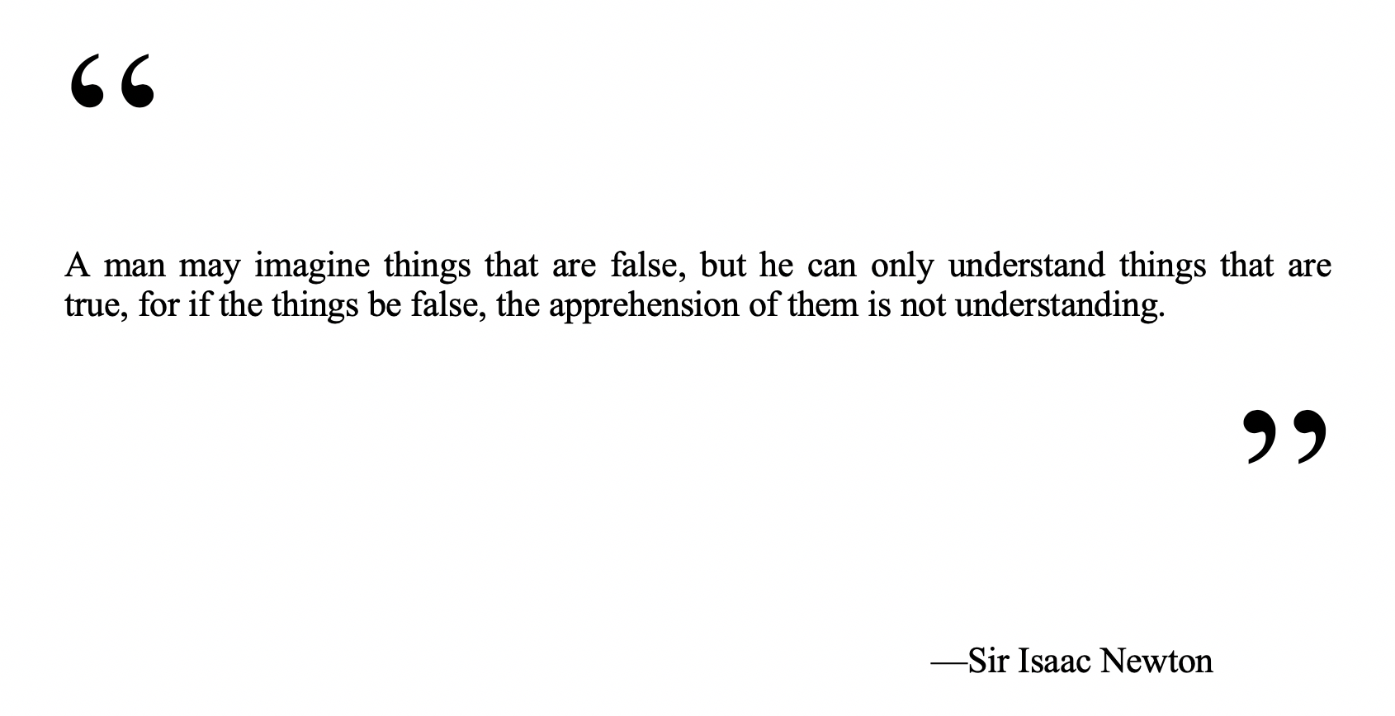

Abstract

This Masters Dissertation outlines the application of deep learning methods on raw data from the Transition Radiation Detector at CERN as well as on simulated data from the Monte Carlo Event Generator Geant4, in order to achieve the following goals:

1. Classification Part I: Particle identification; distinguishing between electrons and pions

To this end, various feedforward neural networks, convolutional neural networks, as well as recurrent neural networks were built using Keras with a TensorFlow back-end, resulting in an ultimate pion efficiency of $ε_{π}=$ $1.2\%$ in the $P≤2 GeV$ range, $ε_{π}=$ $1.14\%$ in the $2 GeV<P≤3 GeV$ and $ε_{π}=$ $1.51\%$ in the $3 GeV<P≤4 GeV$ range, all at electron efficiency $ε_{e}≈ 90\%$, using an incrementally trained convolutional neural network, which was fed training data from particles in increasing momentum ranges sequentially, during separate training runs, by saving weights obtained from the previous momentum ranges.

Raw data was extracted from the Worldwide LHC Computing grid using the ROOT data analysis framework, a C++ based platform maintained by physicists at CERN. R and Python were used interchangeably during various stages of data exploration, processing, analysis and model-building.

1. Classification Part II: Distinguishing real data from data generated by Geant4

This stage of the project focused on employing convolutional neural networks towards distinguishing real data from simulated data. Data was simulated using Geant4, a Monte Carlo toolkit which simulates the passage of particles through matter. ROOT was used to reconstruct the simulated data to deliver it in a similar format to that given by raw data after processing. A balanced accuracy score of 91.5% (with Sensitivity = 0.8575 and Specificity = 0.9725) was achieved, using a 2D Convolutional Neural Network.

1. Deep Generative Modeling: Prototyping Variational Autoencoders and various types of Generative Adversarial Networks towards TRD data generation

Various deep generative models were built to take as input raw TRD data and produce simulated observations which are likely under the training data distribution. While results were not as accurate as simulations from Geant4, it is nonetheless worthwhile to see how they performed on this problem.

Acknowledgements

Firstly, I would like to thank my father, Christiaan Gerhardus Viljoen, for all the support – material, emotional and financial – he has selflessly provided to me throughout my life, and particularly towards my higher education journey. You have no idea how much appreciation I have for all the sacrifices you have made for me, and all the advice you have given me.

Secondly, I want to thank my aunt, Professor Emma Ruttkamp-Bloem, for all the mentoring she has provided to me in navigating the world of academia, and for the inspiration that her own academic career instils in me.

Thirdly, I want to thank Dr Thomas Dietel for providing me with this immense opportunity to be part of the largest scientific experiment in human history, and for the rigorous scientific guidance that he has, and continues to provide to me.

Lastly, I would like to thank my larger family, on both my father’s and mother’s side, for providing the loving and stable environment that makes any place we assemble Home.

Computations were performed using facilities provided by the University of Cape Town’s ICTS High Performance Computing team: [hpc.uct.ac.za](http://hpc.uct.ac.za/)

Travel to CERN was paid for by iThemba Labs via the SA-CERN agreement

Table of Contents

1 Introduction 20

1.1 Aims and Motivation 20

1.2 Summary of Work Done & Major Findings 21

1.3 The Structure & Organization of this Dissertation 22

2 High Energy Physics & CERN 24

2.1 A Brief History of Atomic Theory 24

2.2 The Standard Model of Particle Physics 25

2.2.1 Introduction 25

2.2.2 The Fundamental Particles 26

2.2.3 The Fundamental Forces 27

2.2.4 The Higgs Boson 27

2.3 The Quark Gluon Plasma (QGP) 28

2.3.1 Introduction to QGP 28

2.3.2 QGP, the Big Bang and the Micro Bang 29

2.4 CERN 30

2.4.1 Hardware 31

2.4.2 HEP Software 33

3 The ALICE Detector & the Transition Radiation Detector 36

3.1 Interactions of Particles with Matter 37

3.1.1 The Bethe-Bloch Curve 37

3.1.2 Transition Radiation 38

3.2 The ALICE Detector System 38

3.3 The Transition Radiation Detector 39

3.3.1 TRD Design Synopsis 40

3.3.2 TRD Measurement Mechanism 40

4 Deep Learning 41

4.1 41

4.1.1 Artificial Neural Networks 41

4.1.2 Regularization and Optimization for Deep Learning 43

4.2 Convolutional Neural Networks 47

4.2.1 The Kernel Concept and Motivation for CNNs 47

4.2.2 Pooling 48

4.2.3 The Convolution Function 49

4.3 Generative Models 51

4.3.1 Background: Latent Variable Models 52

4.3.2 Variational Autoencoders 53

4.3.3 Generative Adversarial Networks 56

4.3.4 Variations on the GAN concept used towards Event Simulation in this Dissertation 58

5 Statistical Tests 60

5.1 Hypotheses 61

5.2 Significance Level and Power 62

5.3 Statistical Tests for Particle Selection 63

6 Data 65

6.1 Data Extraction 66

6.2 LHC Runs Used 66

6.3 Data Structure 66

6.4 Graphical Overview of Data 67

6.4.1 Example Images of Tracklet Signals 67

6.4.2 Alternative ways of visualizing tracklet signals 69

6.4.3 Statistical Analysis of Dataset 70

6.4.4 Exploratory Data Analysis 76

7 Particle Identification 78

7.1.1 Particle Identification in the TRD 78

7.2 82

7.3 Stage 1 of Model Building: Establishing Naïve Benchmarks & Generating Features by Hand 82

7.4 Stage 2 of Model Building: Testing a Large Variety of Architectures and Hyperparameter settings 85

7.4.1 2D Convolutional Neural Networks 86

7.4.2 1D Convolutional Neural Networks 88

7.4.3 LSTM Networks 89

7.4.4 Dense (Fully Connected) Networks 90

7.4.5 Discussion of Most Successful Model from Stage Two of Model Building 107

7.4.6 Summary of Most Successful Models, per Model Type 112

7.5 Stage 3 of Model Building: Focal Loss, Incremental Training per Momentum Bin 113

7.5.1 Data pre-processing 113

7.5.2 Accounting for Class Imbalance without resorting to down-sampling: Custom Focal Loss Function 113

7.5.3 Incremental Model Training, per Momentum-bin 114

8 High Energy Physics Event Simulations 121

8.1 Deep Learning for Distinguishing Geant4 data from real data 122

8.1.1 Geant4 Configuration and Simulation 122

8.1.2 Data Pre-processing 122

8.1.3 Distinguishing Geant4-simulated Pions from Real Pions 125

8.2 Deep Generative Models Towards Event Simulation 130

8.2.1 Variational Autoencoders 131

8.2.2 Generative Adversarial Networks: Stage One (Adapting Out-of-the-box Networks to this Problem) 133

8.2.3 GANs Stage 2 141

9 Discussion and Conclusions 142

9.1 Discussion 143

9.1.1 Particle Identification Using Deep Learning 143

9.1.2 Deep Generative Models towards High Energy Physics Event Simulations 147

9.2 Conclusions 153

9.2.1 Particle Identification 153

9.2.2 Simulations 154

9.3 Outlook and Future Work 154

9.3.1 Particle Identification 154

9.3.2 Simulations 154

9.3.3 Outlook 155

10Bibliography 156

Appendix A 159

List of Tables

Table 1: The twelve fundamental fermions. 26

Table 2: Confusion Matrix for Particle Identification 110

Table 3 117

Table 4: Confusion Matrix for distinguishing between Geant4 vs Real Data 126

List of Figures

Figure 1: Simplified diagram of classical states of matter and transitions between them, with the Vacuum added as a fifth element, providing the space in which matter exists [3], reproduced and modified from [4]. 28

Figure 2: Phase diagram of hadronic matter [5] 29

Figure 3: The evolution of the Universe, from the Big Bang to Modern Day [6] 30

Figure 4: CERN facilities in geographical context [15]. 31

Figure 5: The LHC Proton Source, connected to the Duoplasmatron device, which strips electrons off Hydrogen molecules, to produce the beams of protons which eventually collide within the LHC [17] 32

Figure 6: The CERN accelerator complex [19]. 32

Figure 7: Bethe-Bloch curve for various subatomic particles as measured by the ALICE TPC at $s=7TeV$ 38

Figure 8: The ALICE detector system [34] 39

Figure 9: A schematic representation of the components in an MWPC module 40

Figure 16: Illustration of the descent towards zero, of the Binary Cross Entropy Loss Function as ŷ, or $pmodel(y|x)$, approaches the true y. 43

Figure 18: An illustration of the concept of max pooling, using pool-width of 3 with a stride of one (top panel) vs a stride of two (bottom panel) [41]. 49

Figure 19: Illustration of mathematical equivalence of implementing a convolution with unit stride followed by downsampling to implementing a convolution with stride = 2. 51

Figure 23: Training-time VAE 55

Figure 24: Training-time VAE with reparameterization trick to enable backpropagation 56

Figure 25: Testing time VAE 56

Figure 26: Gan Densities during training, close to convergence, P(x) is shown in black, G(z) in blue and D(G(z)) in red 57

Figure 27: Gan Densities during training, once the Algorithm has converged, G(z) matches P(x) perfectly and D(G(z)) outputs 0.5 everywhere 57

Figure 28: An illustration of rejection or acceptance of the null hypothesis, under the assumed distributions of $H0$ and $H1$, when t falls in the critical region $t>tcut$ 62

Figure 29: Filled contour map of a single pion tracklet’s signal, with pads along the *x* axis (columns) and timebins along the *y* axis (rows) 69

Figure 30: 3D surface plot of the signal of a single pion tracklet's signal, with timebins along *x*, pads along *y* and pulse height along *a*. 69

Figure 31: 3D histogram of a single electron tracklet's signal, with pads along *x*, timebins along *y* and pulse height along *z*. 70

Figure 32: Number of Entries per TRD Layer Number, for all Runs 71

Figure 33: Number of Particles, per Particle ID, across all runs 72

Figure 34: Number of Particles (electrons and pions) in each of a set of defined momentum bins 73

Figure 35: Energy Loss per Unit Path Length as a function of Momentum, for Electrons and Pions 73

Figure 36: Don't know if I should rather keep this graph, it looks cleaner, there's a weird bump in the 2GeV range when looking at P instead of P_T 74

Figure 37: Time Evolution of the Average Pulse Height Signal, per Particle ID (for tracklets from the entire momentum range) 75

Figure 38: Pulse height as a function of time for 4 randomly sampled electrons 75

Figure 39: Pulse height as a function of time for 4 randomly sampled pions 76

Figure 40: Mean pixel Values per TRD layer, for all runs 77

Figure 10: Time evolution of the TRD signal, measured as pulse height vs drift time for electrons and pions (both at p = 2GeV) [37]. 78

Figure 11: Reference distributions for most probable signal dependence on βγ in the TRD, i.e. from measurements taken in pp-runs, test beams and measurements from cosmic rays [37]. 79

Figure 12: Truncated mean signal (dE/dx + TR) for various charged particles as measured for p-Pb collisions at $5.02$ $TeV$. This method allows for particle identification of light particles and hadrons [37]. 80

Figure 13: Normalised distribution of charge deposition for electrons and pions in a single TRD chamber [37]. 80

Figure 14: Pion efficiency as a function of electron efficiency for the various particle identification methods discussed [37]. 82

Figure 15: Momentum dependence of pion efficiency for various methods (where electron efficiency is at 90%) 82

Figure 45 83

Figure 46: Training and Loss Curves for Naïve Benchmark Deep Learning Model 83

Figure 47 84

Figure 48 84

Figure 49: Sigmoid vs Tanh activation 89

Figure 50 91

Figure 51 92

Figure 52 93

Figure 53 94

Figure 54 95

Figure 55 96

Figure 56 97

Figure 57 98

Figure 58 99

Figure 59 100

Figure 60 101

Figure 61 102

Figure 62 103

Figure 63 104

Figure 64 105

Figure 65 106

Figure 66: Particle Identification Model Architecture 107

Figure 67: Training vs Validation Accuracy 108

Figure 68: Training vs Validation Loss 108

Figure 69: t-statistic selection allowing for 90% electron efficiency 109

Figure 70: Combined output probabilities for true electrons (1, blue) and true pions (0, red) 109

Figure 71: Weights of first convolutional layer 110

Figure 72: Weights of second convolutional layer 111

Figure 73: Weights of third convolutional layer 111

Figure 74: Weights of fourth convolutional layer 112

Figure 75: Focal Loss where true class is 1. 114

Figure 76 115

Figure 77 115

Figure 78 116

Figure 79 117

Figure 80 118

Figure 81: Summary of incrementally trained (with uncalibrated dataset, partitioned by increasing momentum range) Convolutional Neural Network 119

Figure 82: Summary of previous work done on Particle Identification using calibrated data from the TRD 120

Figure 83: Eta distributions for real and Geant4 simulated data 123

Figure 84: $nσπ$ estimate (TPC) distributions for real and Geant simulated data, before cut 123

Figure 85: nsigma pion distributions after applying cut 124

Figure 86: Momentum distributions for both real and Geant4 simulated data, before cut 124

Figure 87: Momentum distributions after cut 125

Figure 88: Training loss and accuracy curves for training and validation data 125

Figure 89: Model architecture for distinguishing real from Geant4-simulated data 126

Figure 90: Distribution of ADC values for simulated data 127

Figure 91: Distribution of ADC values for real data 127

Figure 92: Distribution of the number of pads with no data per image for simulated data 128

Figure 93: Distribution of the number of pads with no data per image for real data 128

Figure 94: Distribution of mean ADC value per image for simulated data 129

Figure 95: Distribution of mean ADC value per image for real data 129

Figure 96: 3D Histograms of Four Randomly Sampled Geant4 Pion Tracklets 129

Figure 97: 3D Histograms of Four Randomly Sampled Real Pion Tracklets 130

Figure 98: Average Pulse-height as a function of time-bin for Real and Geant4-simulated pion tracklets 130

Figure 99: Encoder 131

Figure 100: Decoder 132

Figure 101: Four examples of simulated data created using a Variational Autoencoder 133

Figure 102: Training accuracy and loss curves for training vs validation data 133

Figure 103: Accuracy Paradox 143

Figure 104: Example of a 2D-Convolutional Network training to high validation accuracy 144

Figure 105: Example of an LSTM Network training to high validation accuracy 144

Figure 106: Example of a 1D-Convolutional Neural Network training to high validation accuracy 144

Figure 107: Running a successful model for twice the number of epochs results in minimal gains and eventually, results in overfitting 145

Figure 108: No Dropout vs Same Model with too much Dropout 146

Figure 109: Gaussian Noise with σ=0.2 147

Figure 110: Real images 148

Figure 111: Autoencoder outputs 149

Figure 112: An illustration of Mode Collapse 150

Figure 113: Illustrating the effect of Batch normalization to prevent output images from looking highly similar 151

Figure 114: Illustrating how convolutional architectures in a GAN setup results in features that might exist in the training distribution, but do not appear in the right place 152

Figure 115: Least squares GAN after 94600 epochs 153

Figure 116: Least squares GAN after 387600 epochs 153

Figure 117: Least squares GAN after 449000 epochs 153

List of Abbreviations and Acronyms

|  |  |
| --- | --- |
|  |  |
| ALICE | A Large Ion Collider Experiment |
| TRD | Transition Radiation Detector |
| CERN | European Organization for Nuclear Research |
| QGP | Quark Gluon Plasma |
| LHC | Large Hadron Collider |
| WLCG | Worldwide LHC Computing Grid |
| QCD | Quantum Chromodynamics |
| ML | Machine Learning |
| PbPb | Lead-Lead Collisions |
| $$e^{-}$$ | Electron |
| $$π$$ | Pion |
| QED | Quantum Electrodynamics |
| p | Proton |
| n | Neutron |
| $$v_{e}$$ | Electron Neutrino |
| $$v_{μ}$$ | Muon Neutrino |
| $$v_{τ}$$ | Tau Neutrino |
| LSTM | Long Short-Term Memory |
| VAEs | Variational Autoencoders |
| GANs | Generative Adversarial Networks |
| nσ-electron | The TPC’s estimate for how many standard deviations away from the expected signal for an electron a particle is |
| eV | Electron Volt |
| u | Up quark |
| d | Down quark |
| s | Strange quark |
| c | Charm quark |
| b | Bottom quark |
| t | Top Quark |
| $$μ^{-}$$ | Muon |
| $$τ^{-}$$ | Tau lepton |
| EWT | Electroweak Theory |
| c | The speed of light |
| $$〈O〉$$ | Vacuum expectation value |
| QFT | Quantum Field Theory |
| g | Coupling strength of standard model interaction vertices |
| $$τ$$ | Characteristic mean lifetime of subatomic particles |
| HEP | High Energy Physics |
| fm | Femtometer |
| s | Seconds |
| T | Temperature |
| UNESCO | United Nations Educational, Scientific and Cultural Organization |
| TB | Terabytes |
| RAM | Random Access Memory |
| GiB/s | Gigabytes per second |
| RHIC | Relativistic Heavy Ion Collider |
| Z | Atomic number |
| $$H_{2}$$ | Hydrogen |
| $$\sqrt{s}$$ | Centre of Mass Energy |
| p | Momentum |
| pPb | Proton-Lead Collisions |
| Pb | Lead |
| PS | Proton Synchrotron |
| SPS | Super Proton Synchrotron |
| NbTi | Niobium-titanium |
| K | Degrees Kelvin |
| °C | Degrees Celcius |
| T | Tesla |
| $$P_{vac}$$ | Vacuum Pressure |
| $$atm$$ | Atmosphere |
| ATLAS | A Toroidal LHC Apparatus |
| CMS | Compact Muon Solenoid |
| LHCb | Large Hadron Collider beauty |
| TOTEM | The TOTal cross section, Elastic scattering and diffraction dissociation Measurement at the Large Hadron Collider |
| MoEDAL | The Monopole & Exotics Detector at the LHC |
| OOP | Object Oriented Programming |
| GNU | Gnu's Not Unix |
| OS | Operating System |
| $$T_{c}$$ | Critical Temperature |
| m | Meter |
| ITS | Inner Tracking System |
| SPD | Silicon Pixel Detectors |
| SDD | Silicon Drift Detectors |
| SSD | Silicon Strip Detectors |
| dE/dx | Energy loss per unit pathlength |
| $$P_{T}$$ | Transverse Momentum |
| TPC | Time Projection Chamber |
| TOF | Time of Flight |
| m² | Square meters |
| ps | Picoseconds |
| HMPID | Ring Imaging Cherenkov Detectors |
| $${Xe-CO}_{2}$$ | Xenon - Carbon Dioxide Gas |
| PHOS | Photon Spectrometer |
| EmCal | Electromagnetic Calorimeter |
| $$PbWO_{4}$$ | Lead Tungstate |
| V0 | ALICE V0 Detector |
| T0 | ALICE Fast timing and trigger detector |
| PMD | Photomultiplicity detector |
| FMD | Forward multiplicity detector |
| ZDC | Zero Degree Calorimeters |
| cm | Centimetre |
| $$η$$ | Pseudorapidity |
| MWPC | Multi-wire Proportional Chamber |
| ns | Nanoseconds |
| ADC | Analog to digital converter |
| γ | Relativistic Factor |
| LQ1D | One-dimensional likelihood |
| LQ2D | Two-dimensional likelihood |
| AI | Artificial Intelligence |
| MLPs | Multilayer Perceptrons |
| ReLU | Rectified Linear Unit |
| J | Objective function |
| SGD | Stochastic Gradient Descent |
| $$ϵ_{i}$$ | Learning rate at iteration i |
| $$α$$ | Momentum decay parameter |
| v | Velocity |
| $$θ$$ | Parameter set |
| $$g$$ | gradient |
| $$\tilde{θ }$$ | Interim parameter update |
| $$ρ$$ | Length scale |
| Adam | Adaptive Moments |
| CNN | Convolutional Neural Network |
| RNN | Recurrent Neural Network |
| ANN | Artificial Neural Network |
| $$s^{(t)}$$ | State of a dynamical system at timestep t |
| Z | Latent space |
| I | Identity matrix |
| $$D$$ | Kullback-Leibler divergence |
| $$μ$$ | Mean |
| $$Σ$$ | Multidimensional standard deviation |
| σ | Standard deviation |
| D | Discriminative Neural Network |
| G | Generative Neural Network |
| BiGANs | Bidirectional Generative Adversarial Networks |
| LSGANs | Least Squares Generative Adversarial Networks |
| $$H_{0}$$ | Null Hypothesis |
| t | Test statistic |
| $$t_{cut}$$ | Threshold value for test statistic |
| $$α$$ | Significance level |
| $$1-β$$ | Power |
| $$ε_{e}$$ | Electron Efficiency |
| $$ε_{π}$$ | Pion Efficiency |
| PDG | Particle Data Group |
| $$V_{0}$$ | Primary vertex |
| $$γ_{1}$$ | Skewness |
|  |  |

# Introduction

## Aims and Motivation

This Masters Dissertation seeks to apply cutting edge techniques in Machine Learning (ML) towards:

* Particle identification of electrons and pions, from raw signal data produced by these particles as they traverse the Transition Radiation Detector (TRD), using deep feedforward neural networks, convolutional neural networks and recurrent neural networks, specifically Long-Short-Term Memory (LSTM) networks
* Distinguishing between real data and data simulated by the Geant4 Monte Carlo simulation environment
* Prototyping of variational autoencoders and Generative Adversarial Networks towards the simulation of High Energy Physics (HEP) collision events

The motivation for each of these elements is as follows:

* Accurate particle identification (in particular, electron samples that are as pure as possible) allows physicists at the ALICE (A Large Ion Collider Experiment) experiment to study the properties of the Quark Gluon Plasma (QGP), the primordial state of matter in the early universe. Since this deconfined state of matter rehadronizes quite soon after forming, it cannot be studied directly, but only via its decay products, of which the electron is one. To this end, having an electron sample which is as pure as possible is desirable and being able to accurately reject pions from the electron sample, whilst keeping as many as possible actual electrons in the sample under investigation, is a major concern
* Being able to distinguish Monte Carlo simulations from real data, could be indicative that Monte Carlo simulations, used for calibration and calculations of detector response functions, etc. are not accurate enough and that they could potentially be tuned via various parameter settings in future studies to increase their accuracy
* Using deep generative models such as Variational Autoencoders (VAEs) and Generative Adversarial Networks (GANs), instead of Monte Carlo simulations, could be a desirable future course of action, since these simulations are extremely fast compared to Geant4 simulations; but their practical use is contingent on whether they provide comparable accuracy to Geant4 simulations, as well as their customizability, e.g. is it possible to specify which particle, and at what momentum you want to simulate?

A variety of different software packages were utilized during the course of this project, including ROOT for data extraction, Geant4 for event simulation, Python and R for statistical analysis and Keras with a Tensorflow back-end for deep learning implementations.

## Summary of Work Done & Major Findings

The lowest pion efficiencies that were obtained per momentum bin are as follows: $ε_{π}=$ $1.2\%$ in the $P≤2 GeV$ range, $ε_{π}=$ $1.14\%$ in the $2 GeV<P≤3 GeV$ and $ε_{π}=$ $1.51\%$ in the $3 GeV<P≤4 GeV$ range, all at electron efficiency $ε_{e}≈ 90\%$. These results were obtained using an incrementally trained convolutional neural network as described in **Error! Reference source not found.**.

The highest balanced accuracy in distinguishing Geant4 simulated data from true raw data was 91.5%. This was also achieved using a convolutional network, discussed in **Error! Reference source not found.**.

In terms of Deep Generative Models, Variational Autoencoders gave results that look quite realistic to the human eye, but which could be easily distinguished from real data using a convolutional neural network.

Several variations on the Generative Adversarial Network concept was tested out, each of which performed in vastly different ways, but none of these were found to generate samples that looked as realistic as those obtained from Variational Autoencoders or which could compete with Geant4 simulations.

## The Structure & Organization of this Dissertation

Chapter 2: High Energy Physics begins with a history of atomic theory from Democritus to the Standard Model of Particle Physics, outlines the fundamental particles and forces and the standard model vertices, which explains their interactions; then touches upon two ways in which particles interact with matter relevant to understanding the data used in this thesis, followed by a quick overview of the Quark Gluon Plasma. Next, the European Organization for Nuclear Research (CERN) experiment is discussed, in terms of its establishment, particle acceleration hardware and the various experiments conducted at the LHC today, as well as a discussion of its currently used software packages for data analysis (ROOT) and simulation (Geant4).

Chapter 3: The ALICE Detector & the Transition Radiation Detector goes into detail about the ALICE detector, focussing on the Transition Radiation Detector (TRD) and methods currently used for particle identification in the TRD, with a brief overview of their performance.

Chapter 4: Deep Learning introduces Deep Learning within the larger context of Machine Learning and Artificial Intelligence, then discusses the original theory upon which modern deep learning is based: Rosenblatt’s perceptron. After this, the mathematical background for deep learning used in this dissertation is discussed, including feedforward neural networks, backpropagation, methods for regularization, convolutional- and recurrent neural networks and two types of generative models, namely variational autoencoders and generative adversarial networks.

Chapter 5: Statistical Tests is a short chapter explaining the statistical tests used for particle selection in this thesis at the hand of: hypotheses, significance level and power. It also introduces the concepts of electron- and pion efficiency, which is important in understanding the Results section of this dissertation.

Chapter 6: Data outlines the format of the data used in this thesis, along with some example plots of TRD tracklet signals, electron and pion counts per run, Bethe Bloch curves for electrons and pions per run as well as nσ-electron plots for electrons and pions per run.

Chapter **Error! Reference source not found.** is the **Error! Reference source not found.** section of this dissertation.

Chapter **Error! Reference source not found.** is the **Error! Reference source not found.** section of this dissertation, where only the most successful results are discussed.

Chapter 9 contains the Discussion and Conclusions, including a deeper analysis of results, as well as an outline of future work which can be done in this area.

# High Energy Physics & CERN

## A Brief History of Atomic Theory

The earliest model for the atom can be traced back to 400 BCE, when Democritus proposed that the entire universe consisted of fundamental particles, or “Atoms”, which cannot be divided any further.

In 1803, Dalton refined this model by stating that these indivisible atoms can have distinguishing chemical and physical traits and that they combine to form chemical compounds.

Then, in 1987, JJ Thompson discovered the electron and proposed a – subsequently proven to be incorrect – theory for subatomic structure, in which negatively charged electrons were embedded amongst positive charges within an atom.

Rutherford, Marsder and Geiger disproved this model in 1911, with their seminal alpha-particle scattering experiment and put forth a more accurate model for the atom, in which most of the atom consists of empty space, with a dense core of positively charged protons surrounded by an electron shell.

In 1913, Bohr refined this model further, indicating that electrons orbit the positively charged atomic core at distinct energy levels. While this model did explain the emission spectrum of Hydrogen, it could not explain the emission spectra of any of the other elements.

Between 1924 – 1928, De Broglie, Heisenberg and Schrödinger each separately developed a similar quantum paradigm, where electrons have wave-like properties and appear in much more complex orbitals. This is still the accepted theory of atomic structure today.

There have been some additions made to the quantum theory, as new information has come to light: a neutral subatomic particle, the neutron, was discovered in 1932, which solved the puzzle of why atoms were found to be nearly twice as heavy as expected based on proton number; this discovery also disproved Dalton’s second law, which stated that all atoms of a specific element were identical; which resulted in the concept of isotopes (atoms with the same number of protons, but differing numbers of neutrons) being proposed. In the same year, Cockroft and Walton split the atom for the first time, by bombarding Lithium atoms with protons, splitting them into two Helium particles.

The 1950s brought about a new era in nuclear physics, in which particle accelerators with collision energies of a few hundreds of MeVs became affordable, along with cosmic ray and inelastic proton-scattering experiments; since this time, a whole host of subatomic elements have been discovered, many of which are unstable. The discovery of these new particles has led, over time, to the development and refinement of the modern Standard Model of Particle Physics.

## The Standard Model of Particle Physics

### Introduction

The Standard Model of Particle Physics is a framework which allows us to understand the fundamental structure and dynamics of our universe in terms of elementary particles, where all interactions between elementary particles are similarly facilitated by an exchange of particles. In summary, based on our current understanding, our entire universe consists of a very sparse array of fundamental particles once we delve into the subatomic realm [1].

At an energy scale of ${10}^{0}$ electron Volts (an electron Volt, eV, is a unit of energy, equivalent to the amount of work required to accelerate a single electron through a potential difference of 1 Volt), the low energy manifestation of Quantum Electrodynamics (QED) allows atoms to exist in bound states with negatively charged electrons ($e^{-}$) orbiting a positively charged nucleus consisting of positively charged protons ($p$) and electrically neutral neutrons ($n$), based on the electrostatic attraction of these opposing electrical charges [1].

Quantum mechanics explains the emergence of unique physical properties in different elements, which arise from their exact electronic structures. Quantum Chromodynamics (QCD) is the fundamental theory of the strong interaction, which binds protons and neutrons together within the nucleus of the atom. Similarly, at this energy scale, the weak force causes nuclear β-decays of radioactive isotopes and is involved in the nuclear fusion processes that occur within stars; the nearly massless electron neutrino ($v_{e}$) is produced during both of the abovementioned processes [1].

Therefore, almost all physical phenomena that occur under normal circumstances can be explained by the Electromagnetic-, Strong- and Weak Forces, Gravity (which is very weak, but explain the large-scale structure of the universe), and just four particles: the electron, proton, neutron and electron neutrino [1].

### The Fundamental Particles

At higher energy scales, protons and neutrons are understood to be bound states of truly fundamental particles called quarks, in the following manner: protons consist of two up-quarks and a down-quark p(uud), whereas neutrons consist of two down-quarks and an up-quark n(ddu) [1].

At the lowest energy level of the standard model, the first generation of particles are then the electron, electron neutrino, the up-quark and the down-quark; these are currently considered to be truly elementary, in that they cannot be subdivided [1].

Higher energy scales, such as those achieved at modern particle accelerators, result in the second and third generation of the four elementary particles; these are heavier versions of the first generation: for example, the muon ($μ^{-}$) is essentially a version of an electron which is 200 × heavier, i.e. $m_{} 200 m_{e}$. The tau-lepton ($τ^{-}$) is the third generation of the electron, and is much heavier, i.e. $m_{τ }≈3500{ m}_{e}$. These mass differences do have physical consequences, but the fundamental properties and interactions of the various generations remain identical [1].

There hasn’t been any evidence of further generations than these three, and so – according to current understanding – all matter in the universe seems to be circumscribed by the following twelve fundamental fermions, reproduced from [1]:

Table 1: The twelve fundamental fermions.

|  |  |  |  |  |  |  |
| --- | --- | --- | --- | --- | --- | --- |
| Leptons | | | | Quarks | | |
|  | Particle | Q | Mass/GeV | Particle | Q | Mass/GeV |
| First Generation | Electron ($e^{-}$) | -1 | 0.005 | Down (d) | -1/3 | 0.003 |
| Neutrino ($v_{e}$) | 0 | < ${10}^{-9}$ | Up (u) | +2/3 | 0.005 |
| Second Generation | Muon ($μ^{-}$) | -1 | 0.106 | Strange (s) | -1/3 | 0.1 |
| Neutrino ($v_{μ}$) | 0 | < ${10}^{-9}$ | Charm (c) | +2/3 | 1.3 |
| Third Generation | Tau ($τ^{-}$) | -1 | 1.78 | Bottom (b) | -1/3 | 4.5 |
| Neutrino ($v_{τ}$) | 0 | < ${10}^{-9}$ | Top (t) | +2/3 | 174 |

While it is accepted that neutrinos are not massless, their masses are so small that they have not been precisely determined, however, the upper bounds for the estimated masses for neutrinos are around 9 orders of magnitude smaller than the other fermions [1].

The Dirac equation describes the state of each of the twelve fundamental fermions and indicates that for each fermion there is an antiparticle which has the same mass but opposite charge, which is indicated by a horizontal bar over the particle’s symbol, or a charge symbol of the opposite sign, e.g. the anti-down quark is indicated by d̅, whereas the antimuon is indicated by $μ^{+}$ [1].

Interactions between particles are facilitated by the four fundamental forces, but the effect of gravity at this scale is sufficiently negligible that it can be ignored without loss of accuracy. All particles take part in weak interactions and are therefore subject to the weak force. The neutrinos are all electrically neutral and therefore are not involved in electromagnetic interactions and are, so to speak, invisible to this force. Quarks carry what is termed as “colour charge” by QCD and are therefore the only particles that feel the strong force [1].

The strong force confines quarks to bound states within hadrons and quarks are therefore not freely observed under normal circumstances [1].

### The Fundamental Forces

Historically, Newton stated that matter could interact with any other matter without the mediation of direct contact and classical electromagnetism explained the electrostatic interaction between particles using fields [1].

Quantum Field Theory circumvents this non-material explanation and encompasses the description of each of the fundamental forces. Electromagnetism is explained by Quantum Electrodynamics (QED), the Strong Force by Quantum Chromodynamics (QCD), the weak force by the Electroweak Theory (EWT), Gravity has not been explained by the Standard Model yet; therefore, Einstein’s General Theory of Relativity is still the best explanation of this force, but it falls within the bounds of Classical Physics. As such, the search to incorporate gravity into the Standard Model is an ongoing area of research and has resulted in exciting new theoretical research avenues such as string theory and loop quantum gravity arising [1].

Looking at electromagnetism, the interaction between charged particles occurs via the exchange of massless virtual photons, which explains momentum transfer via a particle exchange and circumvents the issue of a non-physical potential as the medium of interaction [1].

Similarly, there are virtual particles (gauge bosons) for both the Strong Force (i.e. the massless gluon) and Weak Force (i.e. $W^{+}$ and $W^{-}$ bosons, which are around 80 times heavier than the proton; and the Z boson, which facilitates a weak neutral-current interaction). The gauge bosons all have spin 1, compared to the fermions whom all have spin ½ [1].

### The Higgs Boson

The Higgs Boson, whose existence was confirmed by the CMS and ATLAS collaborations at CERN in 2012, but proposed in 1964 by three separate theoretical papers, breaks rank with the other particles outlined by the standard model in that it is a scalar particle which endows other standard model particles with mass, a property without which all particles would constantly move at the speed of light, $c$ [1].

On their own, all particles are massless, but by interacting with the Higgs Field, which is always non-zero, the Higgs mechanism gives them their distinguishing masses [1].

## The Quark Gluon Plasma (QGP)

### Introduction to QGP

As mentioned above in 2.2.2, quarks and gluons are confined by the Strong Force to remain within the bound states of colour-neutral hadrons (e.g. protons and neutrons) and are therefore never found freely in nature. However, the currently held view of the early universe, predicted by the standard model and supported by over three decades of High Energy Physics experiments and lattice QCD simulations, is that directly subsequent to the Big Bang, the universe was composed of a deconfined state of matter, known as the Quark-Gluon Plasma (QGP) [2].



Figure 1: Simplified diagram of classical states of matter and transitions between them, with the Vacuum added as a fifth element, providing the space in which matter exists [3], reproduced and modified from [4].

Statistical mechanics understands matter as a system in thermal equilibrium. Global observables, such as net charge, temperature and energy density define the average properties of such a system. As these global observables take on different values, radically different average properties can be held by the system, manifesting as different states of matter bounded by phase boundaries, which matter traverses via phase transitions [4], see Figure 1 for an illustration of this process.

If nucleons (protons and neutrons) were truly fundamental, i.e. if they were not bound states of smaller composite elements (quarks and gluons), a density limit of matter would be reached, when compressing it under ever higher pressure conditions. If, however, nucleons were truly composite states, increasing density would eventually cause their boundaries to overlap and nuclear matter would transition from a stable state of colour-neutral three-quark or quark-antiquark hadronic matter to a state of deconfinement, consisting mainly of unbound quarks [4].

Hadrons all have the same characteristic radius of around 1 fm; it has been found experimentally that increasing density (through compression or heating), results in the formation of clusters where there are more quarks within such a hadronic volume than logical partitioning into colour neutral hadrons allows for, thus leading to colour-deconfinement [4].

In Figure 2, a simplified phase diagram of hadronic matter is depicted. Within the hadronic phase, there is a baryonic density/temperature boundary where transitions between mesons (colour-neutral quark-antiquark systems) and nucleons (colour-neutral three-quark systems) occur, (not shown in this diagram). The existence of diquarks as localised bound states within the QGP medium allows for yet another state of matter, the colour superconductor, discussion of which is outside of the scope of this dissertation.

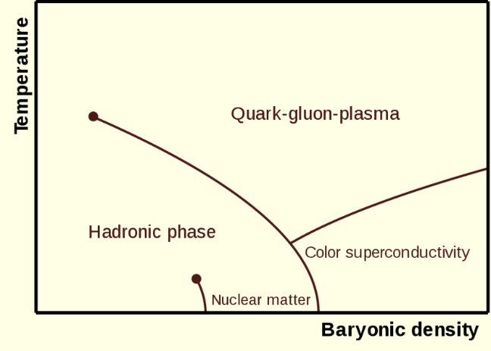

Figure 2: Phase diagram of hadronic matter [5]

### QGP, the Big Bang and the Micro Bang

It is estimated that, during the Plank epoch, which lasted until $t<{10}^{-43}s$ after the Big Bang, the prevailing temperature was T ≃ ${10}^{19}$ GeV, a temperature so high that the principles of general relativity do not apply, and which cannot be understood with present-day physical theory [6].

Shortly after the Planck epoch, following a short exponential inflation phase, quarks and gluons propagated freely in an early deconfined space-time QGP expansion phase of the Universe, down to a temperature of T ≃ 150 MeV, a phenomenon thought to be caused by a change in the vacuum properties of the extremely hot early Universe [2].

To understand how matter was formed in the early Universe, heavy ion collisions, such as the Pb-Pb collisions performed at ALICE, result in a miniscule space-time domain of QGP (which one can refer to as a ‘micro bang’), in which local quark-gluon deconfinement occurs. The subsequent hadronization process, where protons, neutrons and other subatomic particles are formed, leaves traces in the ALICE detector material, giving physicists an indication of how matter arose as the early Universe rapidly cooled down [2].



Figure 3: The evolution of the Universe, from the Big Bang to Modern Day [7]

Since the QGP cannot be detected directly, it is studied via its decay products. Accurately distinguishing between electrons and pions is an important step in this process and as such is the motivation for the particle identification phase of this Masters project.

## CERN

At the end of 1951, a resolution was agreed upon to establish a European Organisation for Nuclear Research (CERN: Conseil Européen pour la Recherche Nucléaire) at an intergovernmental UNESCO meeting in Paris. The final draft of the CERN commission was signed by twelve nations in 1953 [8].

Today, CERN is a truly international organization, with 23 member states ,who contribute to operating costs and are involved in major decision making, a few countries with associate member status or observer status, and non-member countries with co-operation agreements, including South Africa [9].

CERN’s research mandate revolves around finding answers to fundamental questions about the structure and evolution of our universe, as well as its origins; it aims to achieve these goals by providing access to its particle accelerator facilities and compute resources to international researchers, who perform research that advances the forefront of human knowledge, for the benefit of humanity as a whole. As such, CERN is politically neutral and advocates for evidence-based reasoning, knowledge transfer from fundamental research to industry and grass-roots development of future generations of scientists and engineers [10].

### The Large Hadron Collider

The Large Hadron Collider (LHC), located under the Franco-Swiss border (see Figure 4 for geographical context), boasts an intricate system of particle accelerators and -detectors. The LHC is currently the largest and most powerful particle accelerator in the world, with a circumference of $\sim 27km$ and a centre of mass energy of $E_{CM}=13 TeV$ [11].



Figure 4: CERN facilities in geographical context [15].

##### The LHC

Located 50-175 m underground, the LHC is the final step in a chain of successive accelerators feeding beams of accelerated particles into each other at increasing energies, as can be seen in Figure 6.

The LHC’s proton source is a bottle of compressed Hydrogen, which releases its contents into a Duoplasmatron device, which subsequently surrounds the $H_{2}$ molecules with an electrical field and separates it into its constituent protons and electrons [17]. A simplified diagram depicting this process can be seen in Figure 5.



Figure 5: The LHC Proton Source, connected to the Duoplasmatron device, which strips electrons off Hydrogen molecules, to produce the beams of protons which eventually collide within the LHC [17]

A linear accelerator (LinAc2) injects these protons into a booster ring (PS booster) at an energy of 50 MeV, where proton beams are accelerated up to 1.4 GeV, before being injected into the Proton Synchrotron (PS), which accelerates them up to 25 GeV, the Super Proton Synchrotron (SPS) is the final intermediate step before proton beams enter the LHC and proton beams reach an energy of 450 GeV around this accelerator beam before they begin their 20 minute acceleration around the LHC before reaching an energy of 6.5 TeV each [18].

An entirely different protocol is employed to generate the lead ions used in heavy-ion collisions (pPb, PbPb) studied at ALICE. A highly pure Lead (Pb) sample is heated up to a temperature of 800°C and the resulting Pb vapour is ionized by an electron current, which manages to strip a maximum of 29 electrons from a single Pb atom. Those atoms with higher resulting charge are preferentially selected and accelerated through a carbon foil, which strips most ions to ${Pb}^{54+}$. These ions are accelerated through the Low Energy Ion Ring (LEIR) and subsequently through the PS and SPS, where it is passed through a second foil, which strips the remaining electrons and passes the fully ionized ${Pb}^{82+}$ ions to the LHC, where beams of Pb-ions are accelerated up to 2.56 TeV per nucleon [18]; because there are many protons in a single lead ion, the collision energies reached in PbPb collisions reach a maximum of 1150 TeV [18].



Figure 6: The CERN accelerator complex [19].

In order to achieve these high collision energies, a precise system of 1232 dipole magnets is required to keep particles in their circular orbits, with 392 quadrupole magnets employed to focus the two collision beams. The dipole magnets use niobium-titanium (NbTi) cables at a temperature of 1.9 K (-271.3°C). At these temperatures the cables become superconducting and allow the magnetic field to reach the 8.3 T required to bend the beams around the circular LHC ring [18].

The beams themselves are contained within a beam pipe emptier than outer space ($P_{vac}= {10}^{-13}atm$) and are accelerated by electromagnetic resonators and accelerating cavities to 99.9999991% of the speed of light, which means that a beam goes around the 26.659 km LHC ring around 11,000 revolutions/second, resulting in an average bunch crossing frequency of 30 MHz and around a billion collisions per second [18].

#### The CERN Experiments

Collisions at the LHC result in a multitude of particles being produced. Observing the produced particles from different perspectives produces evidence relevant to different research streams; as such, there are several collaborations at CERN which use detectors with differing attributes to study specific areas within the broad area of fundamental subatomic Physics [20].

ATLAS and CMS investigate a very broad range of particle physics. Their independent design specifications allow any new discoveries at one of these detectors, such as the discovery of the Higgs’ Boson in 2012, to be corroborated by the other [20]. Other research avenues pursued at these experiments include the search for additional dimensions as well as the constituent elements of dark matter. The ATLAS detector is the largest particle detector ever built, weighing 7000 tonnes with dimensions 46m × 25m × 25m [21].

ALICE and LHCb are the other two main experiments at CERN and are tasked with the discovery of specific physical phenomena [20]. ALICE focuses on the extreme energy densities present during heavy ion collisions, which leads to the production of the Quark Gluon Plasma, a newly discovered phase of matter thought to have been dominant in the early universe, directly subsequent to the big bang [22]. LHCb investigates subtle distinguishing nuances in the matter-antimatter dichotomy, as evidenced by attributes of the beauty quark [23]. In addition, there are several smaller experiments hosted at the LHC as well.

### HEP Software

#### ROOT

ROOT is an object oriented data analysis platform developed in C++ for High Energy Physics implementations; in addition to its data analysis capabilities, ROOT is also used to transform the petabytes of raw data from collision events at the LHC into more compact and useful representations [24].

The basic ROOT framework provides default classes for most common use-cases and as the HEP community pushes research into new frontiers, they can use the object-oriented programming (OOP) approach followed by ROOT to make use of sub-classing and inheritance to extend existing classes. Similarly, the concept of encapsulation keeps the number of global variables to a minimum and increases the opportunity for structural reuse of code [24].

ROOT libraries are designed with minimal dependencies and as such are loaded as needed. At runtime, libCore.so (the core library) is always invoked; it is composed of the base-, container-, metadata-, OS specification- and ROOT file compression classes. Additionally, the interactive C++ interpreter library libCling.so is used by all ROOT 6 applications, it features a command line prompt with just-in-time interactive compilation to facilitate rapid application development and testing.

When building executables, libraries containing the needed classes are linked to. Extensive documentation is available online at the ROOT reference guides for ROOT 5 [26], the version of ROOT developed and used for LHC run 1 and run 2; and ROOT 6 [27], the version of ROOT developed for LHC run 3, scheduled to start in 2021 after the second long shut down period (LS2).

#### AliROOT

It is a common concept for each experiment at CERN to build software specific to their needs on top of the base ROOT architecture; as such, AliROOT and AliPhysics are built on top of ROOT to provide functionality specific to the ALICE collaboration.

C++ classes define all the code in ROOT, AliPhysics and AliROOT and enables the user to create variables (data) and functions (methods) specific to each class, as its members. A class’s variables are usually accessed via the class’s methods [28].

C++ code is split into header (.h) and implementation (.cxx) files, both having the same name as the class being defined. Header files list all the constants, functions and methods contained in a class. Implementation files use a class’s methods to set and get variables’ values in that class.

The concept of inheritance is frequently utilized to prevent unnecessary repetition of code. Child classes inherit common behaviours and attributes from base/ parent classes and define additional methods and variables that are not common to other classes deriving from the base class.

#### $O^{2}$ Software for Run 3

LHC run 3, scheduled to start in 2020, will require some upgrades to the ALICE detector to accommodate the much higher interaction rate that is being planned for, in order to more precisely measure attributes of heavy flavour hadrons, low mass di-leptons and low-momentum quarkonia. Since these physics probes have a very low signal-to-background ratio, a continuous readout process could result in upwards of 1TB/s of data being generated by the ALICE detector.

This will result in unique challenges, which will need to be met by an upgraded software framework for run 3 and run 4, known as $O^{2}$ (The Online-Offline Software Framework), which is currently being developed.

#### Geant4

Geant4 is a C++ toolkit for simulating how particles traverse through matter. Comprehensive and accurate simulations of particle detectors, using platforms like Geant4, is extremely important, since it provides a theoretical reference against which data can be compared. Should there be any statistically significant discrepancies between simulations and data, it could indicate that phenomena occurred which are not explicable by the Standard Model of Particle Physics and could in rare circumstances lead to the discovery of new fundamental principles of nature [29].

Simulation software typically rests on four key components:

1. Event Generation
2. Detector Simulation
3. Reconstruction
4. Analysis

In a typical High energy Physics Simulation set-up, Geant4 is often used as the Detector Simulation component, tied to an event generator such at Pythia or HIJING, with ROOT used for Reconstruction and Analysis. As such, Geant4 has well-defined interfaces to the other components in the simulation set-up [30].

The following aspects of simulation are implemented in Geant4: materials and geometry of the detector system, fundamental particles and their transition through the detector and external electromagnetic fields, how the detector responds to these processes to generate data and storing said data for downstream analysis [30].

# The ALICE Detector & the Transition Radiation Detector

## Interactions of Particles with Matter

In order to study subatomic particles, they need to be detected. Most particles produced during High Energy Physics Experiments are unstable and therefore decay within a specific characteristic mean lifetime $τ$. Those particles with $τ>{10}^{-10}s$ will traverse several meters before decaying and are therefore directly detectable by particle detectors such as those installed at the Large Hadron Collider (LHC) at CERN. Particles with shorter lifespans are usually detected indirectly, by the interaction of their decay products with detector material [1].

### The Bethe-Bloch Curve

The Bethe-Bloch equation describes the energy lost by a charged particle moving at relativistic speed through a medium, as a result of electromagnetic interactions with atomic electrons. A single charged particle with velocity $v= βc$, passing through a medium with atomic number $Z$ and density $n$, will lose energy as a result of ionisation of the medium, as a function the distance travelled in the medium, according to the Bethe-Bloch formula (Equation 1) [1]:

$$\frac{dE}{dx} ≈ -4πℏ^{2}c^{2}α^{2}\frac{nZ}{m_{e}v^{2}}\left\{ln\left[\frac{2β^{2}γ^{2}c^{2}m_{e}}{I_{e}}\right]-β^{2}\right\}$$

Equation 1

In Equation 1, $I_{e}$ is the effective ionisation potential of the medium. While the $\frac{1}{v^{2}}$ term explains the high energy loss for low energy particles, for high energy particles studied in Modern Particle Physics, where $v≈c$, $\frac{dE}{dX}$ depends logarithmically on ${(βγ)}^{2}$, which is defined by Equation 2. This explains the relativistic rise seen in Figure 7, which illustrates the characteristic energy loss curves for various subatomic particles as measured by the TPC, including the two subatomic particles studied in this project, the pion $π$ and the electron $e^{-}$.

$$βγ=\frac{v/c}{\sqrt{1-{(\frac{v}{c})}^{2}}}=\frac{p}{mc}$$

Equation 2



Figure 7: Bethe-Bloch curve for various subatomic particles as measured by the ALICE TPC at $\sqrt{s}=7TeV$

### Transition Radiation

Transition radiation is radiation emitted by a charged particle as it traverses the boundary between two mediums with different optical properties, no significant energy loss occurs in this process, but the resultant radiation is an important aid in detecting charged particles in HEP experiments [31].

For relativistic particles, the photons emitted in this process extends into the X-ray domain and are highly forward-peaked compared to the direction the particle is moving in; transition radiation yield is increased by stacking multiple radiative boundaries in gas detectors, such as the Transition Radiation Detector (TRD) at ALICE, and placing high atomic number (high-Z) gases within subsequent chambers to absorb the emitted X-ray photons [32].

One of the main aims of this thesis is distinguishing electrons from pions. This is facilitated by the fact that electrons and pions have different characteristic energy loss curves, and particularly at low momenta, electrons have a higher relative energy loss, as well as the fact that electrons emit transition radiation and pions don’t.

## The ALICE Detector System

Colliding heavy ions, such as the Pb-Pb collisions conducted at the LHC and studied at ALICE, offers the most ideal experimental conditions currently achievable for the reproduction of the primordial QGP matter [33]. A transition from ordinary matter to a state of deconfinement occurs at a critical temperature $T_{c}≈2 × {10}^{12 }K$, which is around 100,000 times hotter than the core temperature of our sun [33].

The QGP cannot be probed directly, but is studied via particles produced during the hadronization process that occurs as the QGP cools down and quarks and gluons recombine in various ways; the ordinary-matter particles produced in this process interact with various detector elements and leave traces in the detector material that are generally recorded via electronic signals [33].

The scale of the ALICE detector system is illustrated in Figure 8. The detector weighs 10,000 tonnes and has spatial dimensions 26m × 16m × 16m [22].

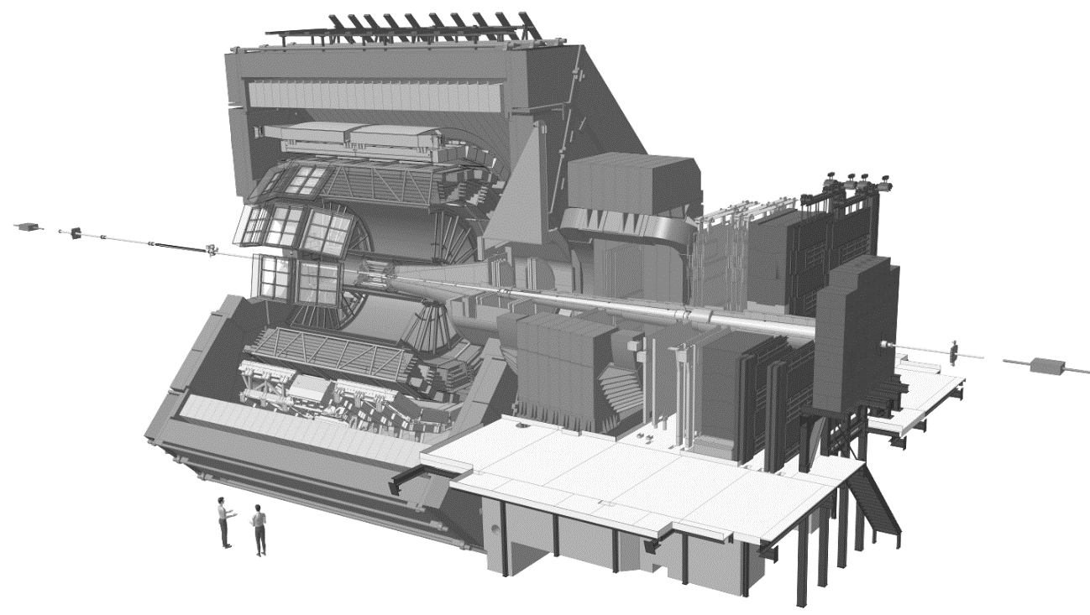

Figure 8: The ALICE detector system [34]

A uniform magnetic field is applied over the detector, to allow particles to propagate in curved paths through the detector geometry, with the extent of curvature of the particle’s track through the detector being inversely correlated to the particle’s momentum; additionally, the sign of charge of a particle can also be deduced from its track curvature [33].

The ALICE detector has a total of 18 stacked subdetectors involved in specific particle tracking tasks, these are broadly divided into: Tracking Systems, situated closest to the collision area, which make use of digital track-reconstruction of particle-detector interaction traces to indicate the path of a particle; these are followed by Electromagnetic and Hadronic Calorimeters, through which particle cascades are generated as particles enter and are absorbed by the calirometric material, with the magnitude of a particle’s energy deposition acting as the signal in these subdetectors; all of which is surrounded by the Muon System in the outermost layer, which detects muons, which interact very weakly with matter and therefore generally travel much further through the detector system [33].

High momentum resolution is obtained in all the detector elements over the high multiplicity densities (number of particles produced per unit volume) present in heavy ion collisions [35]. In addition to heavy ion collisions, lighter ion- as well as proton-nucleus and proton-proton collisions are also performed at ALICE, and this entire momentum range can be accurately measured by the ALICE detector [35].

## The Transition Radiation Detector

At particle momenta above 1 GeV/c, the pion rejection strategy for electron identification employed in the TPC is no longer sufficient. The TRD’s main goal is to expand the range of the ALICE Collaboration’s Physics objectives by providing accurate electron identification capabilities at these high momenta, by supplementing its own data with data obtained from the ITS and TPC; as well as the operation of event triggers that determine whether data from a specific collision should be kept, based on measurements such as collision centrality, amongst others. As an added benefit, the TRD informs the ALICE central barrel’s calibration, and the data it produces is used extensively during track reconstruction and particle identification [36].

### TRD Design Synopsis

Pseudorapidity coverage in the TRD is similar to the other detector elements in the central barrel, i.e. $|η| ≤0.9$. The space between the TOF and TPC detectors is filled by the six layers of the TRD, which are subdivided in azimuthal angle into 18 sectors, with an additional segmentation into 5 sectors occurring along the z-axis. So, in total, we have 18 $×$ 5 $×$ 6 = 540 individual detector elements in the TRD [36] at a radial distance of 2.9 – 3.7 m from the beam axis [37].

Each individual detector element consists of the following broad components: 1) a radiator (4.8 cm thick), 2) a 0.7 cm multiwire proportional readout chamber, and 3) front-end electronics to convert from an amplified particle energy-deposition signal to a digital signal, which is eventually stored if deemed interesting by the multi-tiered TRD trigger system [36].

### TRD Measurement Mechanism

As the name suggests, transition radiation occurs when a particle transits across a dielectric boundary, this radiation is often measured in particle detectors to inform track reconstruction. Multiple boundaries are typically required to increase radiation yield, and since highly relativistic particles emit transition radiation that extends into the X-ray domain, the TRD utilizes gases with high proton-number (Z) to absorb this radiation, resulting in a high yield of energy deposition relative to the energy lost via ionization [36].

The drift time of gas particles within the MWPC provides fine-grained positional information about where the particle tracklet passed through the radiator. The detected signal takes the form of charged gas molecules (ionized via interaction with transition radiation photons and amplified through a chain of interactions between gas molecules), finally being absorbed by a negatively charged wire (anode), this process is shown in Figure 9.



Figure 9: A schematic representation of the components in an MWPC module

# Data

## Data Extraction

Using the AliPhysics installation on the Hep01 cluster in the Physics Department at UCT, an AliRoot macro ana.C (<https://github.com/PsycheShaman/trdML-gerhard/blob/master/ana.C>), modified from a version developed by other collaborators in the SA-ALICE group, was used to extract data from WLCG.

This script interfaces with <https://github.com/PsycheShaman/trdML-gerhard/blob/master/AliTRDdigitsExtract.cxx>, also modified from a previously developed C++ file. TRD digits were extracted and filtered for the runs specified in Chapter 5. By redirecting the C++ standard out to a text file, the relevant data was saved into Python dictionaries for each run.

Jobs were submitted onto the WLCG and monitored using <http://alimonitor.cern.ch/>. Upon completion, data was extracted back onto Hep01 using the aliensh environment and from there was transferred to a local machine using the rsync bash command.

Data was backed up in a semi-private GitLab repository, accessible by CERN members, at <https://gitlab.cern.ch/cviljoen/msc-thesis-data>.

## LHC Runs Used

* 000265377
* 000265378
* 000265309
* 000265332
* 000265334
* 000265335
* 000265336
* 000265338
* 000265339
* 000265342
* 000265343
* 000265344
* 000265381
* 000265383
* 000265385
* 000265388
* 000265419
* 000265420
* 000265425
* 000265426
* 000265499

## Data Structure

A total of 7 735 493 tracklets were extracted from WLCG.

An example of the data obtained for a single track can be viewed at <https://github.com/PsycheShaman/MSc-thesis/blob/master/NEW/example_pythonDict.txt>. This data structure consists of a header section with meta-information about the track, i.e.

* The run-number and event number which the track was obtained from
* The $V_{0}$ Track ID, identifying the primary vertex from which the track originated
* A track number, which is a unique identifier for the track in that event and run number
* A PDG code, which is 11 for electrons -11 for positrons, 211 and -211 for positively and negatively charged pions, respectively
* n-σ electron and n-σ pion which are the number of standard deviations away from the expected electron- and pion signal, respectively
* The transverse momentum of the particle
* Information about the angle at which the particle is traveling, i.e. Eta, Theta and Phi
* dEdX estimate from the TPC
* The detector number, row and column the particle went through in layers 1-6 (indexed from 0-5 because of Python’s indexing strategy)
* The raw data signal caused by the track as it traversed the six layers of the TRD

When read into a single list data structure in R, the full dataset amounts to 19.7GiB.

## Graphical Overview of Data

### Example Images of Tracklet Signals

Below are 10 examples of single tracklet signals, each from a single layer of the TRD. In the images below, the signal for 17 pads in the TRD layer were added (along the rows of the image), in order to ensure that the signal for the tracklet will be captured, in case tracking wasn’t accurate enough. The columns in the images below represent the charge deposited during a specific time bin within the pad, i.e. moving across the pixels in a certain row of the image, gives an indication of the time-evolution of the signal as charge is deposited.









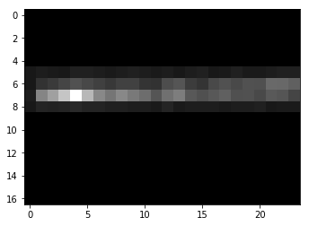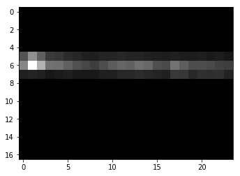

### Alternative ways of visualizing tracklet signals

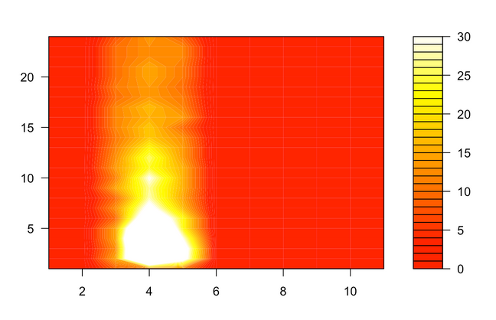

Figure 19: Filled contour map of a single pion tracklet’s signal, with pads along the *x* axis (columns) and timebins along the *y* axis (rows)

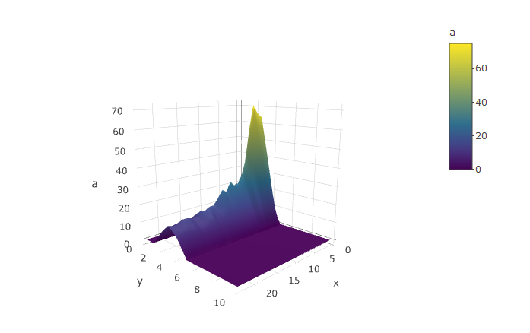

Figure 20: 3D surface plot of the signal of a single pion tracklet's signal, with timebins along *x*, pads along *y* and pulse height along *a*.

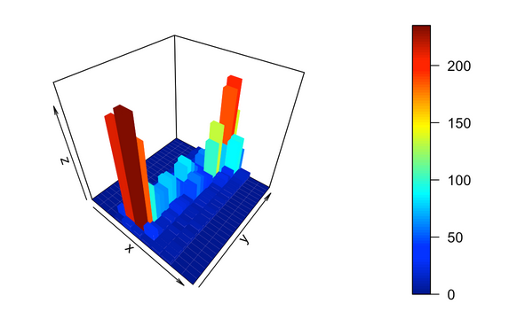

Figure 21: 3D histogram of a single electron tracklet's signal, with pads along *x*, timebins along *y* and pulse height along *z*.

### Statistical Analysis of Dataset

#### Counts

##### Tracks, Tracklets and Missing Data

1 565 438 tracks were picked up from the runs mentioned in 6.1, from these tracks, a total of 7 735 493 tracklets were obtained, which is less than the ideal number of tracklets, i.e. $6 layers×1 565 438 tracks=9 392 628 tracklets$, which one would obtain if every track left a trace in each of the 6 TRD layers.

As can be seen in Figure 22, there is a decreasing number of signals returned per layer, moving outwards from the innermost layers. This is mainly the result of detector elements in the TRD being switched off or not working. Missing data of this type manifests as either an empty list at that layer in the python dictionary, or as a NULL value.

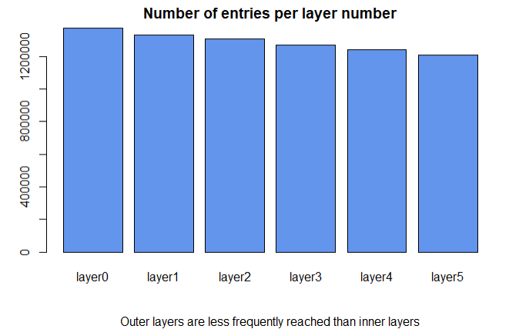

Figure 22: Number of Entries per TRD Layer Number, for all Runs

There is also a second type of missing data: 1 098 636 tracklets returned images, but these images carried no information to assist in particle identification. Every pixel in this type of image was equal to 0.

This number of tracklets with empty arrays, resulted in an additional 14.5% of all pion tracklets and 12.6% of all electron tracklets being removed from the dataset used for training and testing.

Technically, excluding this data also affects the true electron efficiencies reported in this thesis, but this data does not add any additional information, other than the insight that pions result in a slightly higher proportion of empty images compared to electrons.

##### Total Number of Tracklets per Particle ID

Figure 23 illustrates the extreme class imbalance in this dataset, if not accounted for, such a distorted class distribution can result in unwanted results when training Machine Learning models, a problem which is addressed in various ways in Chapter **Error! Reference source not found.**.



Figure 23: Number of Particles, per Particle ID, across all runs

##### Momentum bin counts: number of tracklets per Particle ID

From Figure 24, one can also see how this class distribution differs for particles of different momenta. Particularly, there is a larger proportion of electrons in the lower two momentum bins, i.e. $P≤2 GeV and 2 GeV<P≤3 GeV$. This only partly explains the increased performance in this momentum range (which will be discussed), since electrons are easier distinguishable in this momentum range, according to its characteristic energy loss (Bethe-Bloch), discussed next in 6.4.3.1.4.



Figure 24: Number of Particles (electrons and pions) in each of a set of defined momentum bins

##### Characteristic Energy Loss Curves (Bethe-Bloch)

From Figure 25, the expected increased energy loss of electrons relative to pions, in the low GeV range is apparent. It should be noted that a cut was made on momentum, to keep only tracklets in the $P≤6GeV$ range.

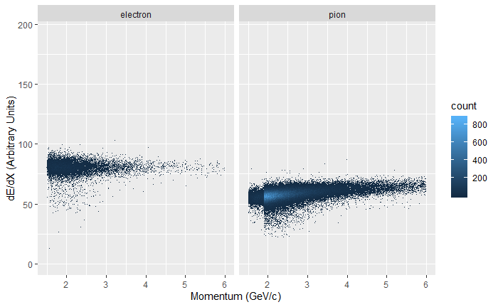

Figure 25: Energy Loss per Unit Path Length as a function of Momentum, for Electrons and Pions

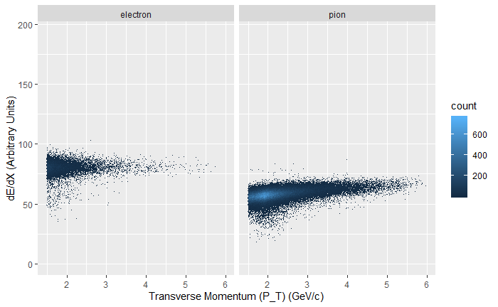

Figure 26: Don't know if I should rather keep this graph, it looks cleaner, there's a weird bump in the 2GeV range when looking at P instead of P_T

##### Average Pulse Height

Figure 27 shows the average pulse height as a function of time, for electrons vs pions, across the entire momentum range; while not as distinct as in Figure 7, which was restricted to tracklets in the 2 GeV range, the characteristic Transition Radiation (TR) signal can be seen for electrons in the later timebins of the plot. The average pulse height for electrons is also higher than that for pions, across all timebins, this fact, in conjunction with the TR signature were the motivation for feeding some particle identification neural networks with the timebins sums of signal arrays, but there are significant fluctuations around this average (as can be seen in Figure 28 and Figure 29), which makes the task much less straight forward than Figure 27 would suggest.



Figure 27: Time Evolution of the Average Pulse Height Signal, per Particle ID (for tracklets from the entire momentum range)

 

 

Figure 28: Pulse height as a function of time for 4 randomly sampled electrons

 



Figure 29: Pulse height as a function of time for 4 randomly sampled pions

### Exploratory Data Analysis

Some additional EDA follows, to look for interesting features in the dataset.

##### Mean pixel Value per TRD Layer

Figure 30 shows how the mean pixel value decreases from the innermost to outermost layers, a first indication that calibration would have increased the pion efficiencies obtained in this project. Much more granular calibration tactics were employed in earlier work done in this area, including chamber gain calibration on a run-by-run basis, as well as pad-by-pad calibration. Since the measurement mechanism employed during data-taking is an analog-to-digital transformation using an immense array of extremely sensitive sensors, the signal obtained from different detector layers and different pads, during different environmental conditions across a long time period, should ideally not be treated as coming from the same measuring device, since these devices will each have their own underlying signal distribution, which was not fed to the models trained in this project.

A form of calibration which feeds some of the above factors of variation as one-hot encoded variables to neural networks for both particle identification and deep generative modelling was investigated, but this meta-information alone explodes to upwards of 42GiB when represented in this fashion. The possibility of encoding this meta-information to a lower dimension using Autoencoders was explored, but the computational cost was deemed to be too much effort for potential pay-off, since there are not equal amounts of signals that originated from each combination of detector, layer and pad, for the neural network to learn useful representations from this information without overfitting, especially to spurious patterns from pads which have produced very little data.

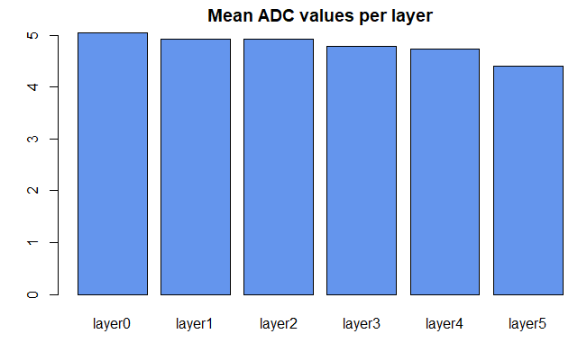

Figure 30: Mean pixel Values per TRD layer, for all runs

# Particle Identification

### Particle Identification in the TRD

At momenta p > 1 GeV/c, the TRD provides electron identification via the measurement of transition radiation. At these momenta, pion rejection (achieved in the TPC via specific energy loss as per characteristic Bethe-Bloch dE/dx curves for pions vs. electrons) is no longer possible. The time evolution of signals generated in the TRD is an important factor in distinguishing between electrons and pions. The electron identification capability is also used to trigger at level 1 [37].

Electron identification and triggering as mentioned above enables the in-depth study of physical phenomena such as jets, the semi-leptonic decay of heavy-flavour hadrons and the di-electron mass spectra of heavy quarkonia; in turn, these phenomena act as probes to study the Quark Gluon Plasma [37].

The TRD signal originally induced on the segmented cathode plane is captured and processed by a preamplifier-shaper circuit, this processed signal is then digitized by a 10 MHz ADC to take samples of the time-evolution of the signal at defined 100 ns intervals [37].

Figure 31 shows the time evolution of the abovementioned signal at p = 2 GeV, for both electrons and pions. The initial peak seen in earlier time-bins on the graph originates from the amplification region of the detector and the plateau that follows is caused by particles moving through the 3 cm drift region in the detector [37].



Figure 31: Time evolution of the TRD signal, measured as pulse height vs drift time for electrons and pions (both at p = 2GeV) [37].

Also evident from Figure 31 is that, in this momentum region, the pulse height of electrons is much higher than that for pions, because electrons have higher characteristic energy loss (dE/dx) in this region [37].

An average of one transition radiation photon in the X-ray domain will be emitted by an electron traveling at a highly relativistic speed (above γ ~ 800), since it will cross many dielectric boundaries in the radiator portion of a detector element, the absorption of this type of photon is evidenced by an additional peak at later times in Figure 31, since it will be absorbed preferentially close to the radiator, adding its signal to the ionization energy of the track [37].

In order to distinguish muons originating from particle-particle collisions from muons originating from cosmic rays, cosmic runs were performed at ALICE; this data, along with energy loss and transition radiation measurements from test-beams at the proton synchrotron (CERN PS) in 2004, and proton-proton (pp-) collisions performed at $\sqrt{s}$ = 7 TeV at ALICE, provides reference distribution data used for particle identification in the ALICE TRD (see Figure 32 for a plot showing the most probable signal dependence on βγ [37]).

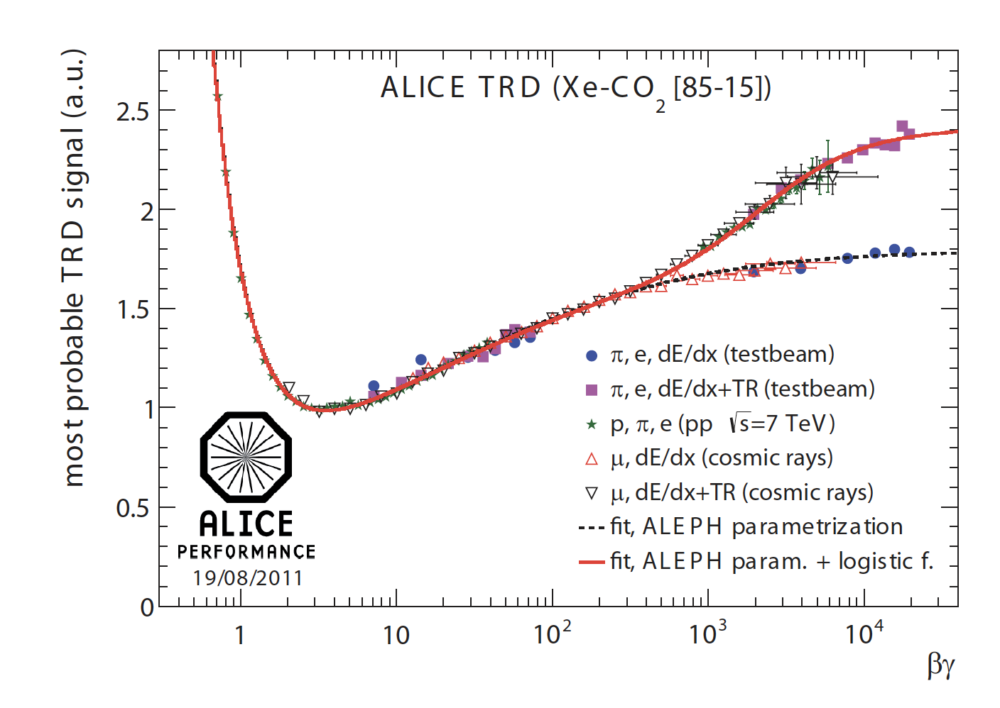

Figure 32: Reference distributions for most probable signal dependence on βγ in the TRD, i.e. from measurements taken in pp-runs, test beams and measurements from cosmic rays [37].

#### Methods used in Particle Identification

Currently, the following methods are employed for particle identification based on TRD data:

1. Truncated mean of the signal
2. One- and two-dimensional likelihood estimations
3. Neural Networks

##### Truncated Mean

The truncated mean signal is the combined signal of Transition Radiation + Specific Ionization Energy; this method focusses on classifying electrons vs pions based on their expected energy loss as per the Bethe Bloch curve shown in Figure 33.

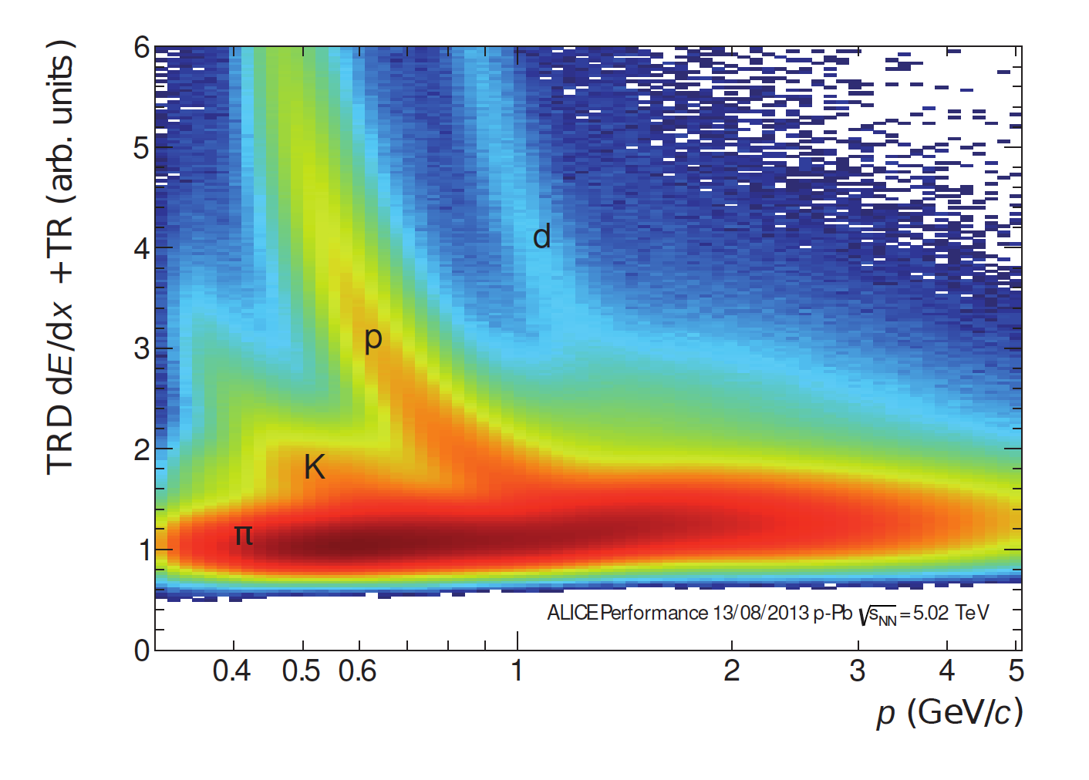

Figure 33: Truncated mean signal (dE/dx + TR) for various charged particles as measured for p-Pb collisions at $\sqrt{5.02}$ $TeV$. This method allows for particle identification of light particles and hadrons [37].

##### One-dimensional Likelihood (LQ1D)

One dimensional likelihood estimation is performed on the total integrated charge left by a particle in a single chamber in the TRD (i.e. a single tracklet). Figure 34 shows that electrons have on average a higher charge deposit, because they experience higher characteristic energy loss in this momentum range, as well as the fact that they emit Transition Radiation and pions don’t [37].



Figure 34: Normalised distribution of charge deposition for electrons and pions in a single TRD chamber [37].

The reference distributions allow maximum likelihood estimations to be carried out on each particle traversing the TRD, i.e. the likelihood of it being a muon, pion, kaon or an electron. Pions are rejected based on momentum-dependent cuts based on the likelihood for electrons, taking into account an electron efficiency score calculated using a clean reference sample of electrons arising from photon conversion [37].

##### Two-dimensional Likelihood (LQ2D)

Two-dimensional likelihood takes the temporal evolution of the signal (Figure 31) into account by splitting the signal into two time-bins and summing the charge in each bin and calculating the likelihood based on pure pion- and electron samples from collision data [37].

##### Neural Networks

A neural network was trained using a similar approach as LQ2D, but instead of splitting and summing over two time-bins, the input feature-set to the neural network was obtained by splitting into seven time-bins and summing the charge over each bin, respectively [37].

#### Particle Identification Accuracy

To calculate the accuracy of the abovementioned methods, clean reference samples were used. The separating power of these approaches are often expressed as pion efficiency (the fraction of pions incorrectly classified as electrons, i.e. the false positive rate or fallout rate) at a specific electron efficiency (the fraction of electrons correctly identified, i.e. the true positive rate or sensitivity) [37].

Figure 35 shows the obtained pion efficiency for the methods discussed above, as a function of electron efficiency, it is clear from this plot that the misidentification of pions as electrons (False Positive Rate) is reduced substantially by the LQ2D and Neural Network techniques, compared to truncated mean- and LQ1D methods, and that the temporal evolution of the signal is therefore a highly informative feature for particle identification [37].

It is important to note that pion suppression (the inverse of pion efficiency) is hampered when a particle passes through fewer than the available six layers of the TRD, and that electron efficiency is sometimes sacrificed during analysis to obtain a more pure sample [37].

Figure 36 shows how pion efficiency depends on momentum for the four methods under discussion, data is plotted for samples where electron efficiency of 90% is obtained. LQ1D and LQ2D are quite accurate at low momenta where the emission of transition radiation commences, but their separating power decreases at higher momenta as transition radiation production saturates and pions deposit more energy, making it harder to tell them apart. The truncated mean method performs poorly at high momenta, since transition radiation with its attendant high charge deposition is more likely to be removed during the truncation procedure [37].

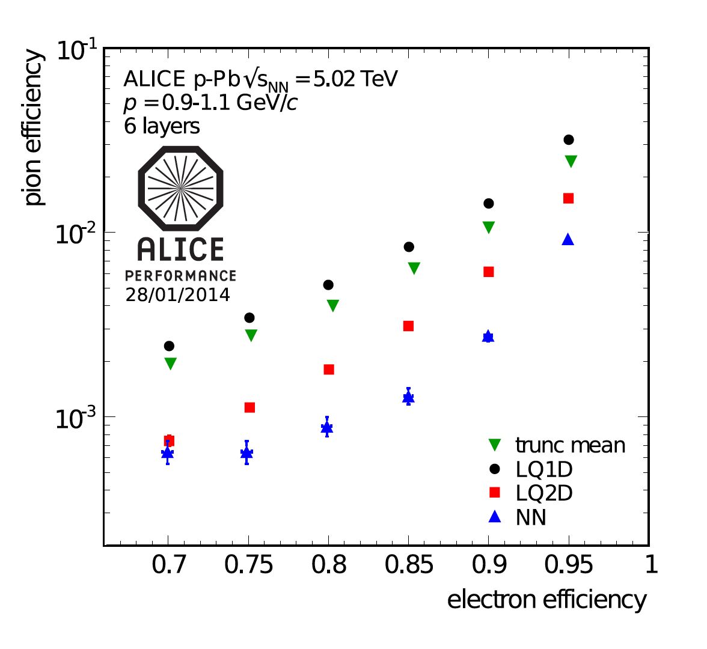

Figure 35: Pion efficiency as a function of electron efficiency for the various particle identification methods discussed [37].



Figure 36: Momentum dependence of pion efficiency for various methods (where electron efficiency is at 90%)

## Artificial Neural Networks

At its most basic level, an artificial neural network (ANN) is an approximation of a mapping function $f_{a}$, which maps from a set of input features $x_{i} ; i=\{1,2,…,n\}$ to a response, $y$. Feedforward neural networks have one-way information flow from input features to output, whereas recurrent neural networks have feedback connections [38].

Also called multilayer perceptrons (MLPs), deep feedforward networks are composed of an arbitrary number of nested approximating mapping functions, of the form:

$$f\left(x_{i,..,n}\right)= f_{a}^{m}(f_{a}^{…}(f_{a}^{2}(f_{a}^{1}(x_{i,…,n}))))$$

Equation 3

The superscript of these functions, $f^{.}$, indicates the layer index of the function in an ANN, with $m$ indicating the depth of such a neural network. It is this concept of chained functions of arbitrary depth from which the term Deep Learning is derived [39].

The process of training such a network, $f$, to give the closest approximation to the desired output, $y$, is an iterative process, involving passing many observations, each having the same feature set $x_{i,…,n}$ through the MLP, assessing the output, $ŷ$, according to an error metric, $E$, and individually adjusting each of the mapping functions $f_{a}^{j,…,m}$ according to their contribution to the differential of the magnitude of error at the conclusion of each training step $k$. In other words, a parameter set $θ$, pertaining to each $f_{a}^{j}$ is iteratively adjusted according to $\frac{∂E_{k}}{∂f_{a}^{j}}$. [38].

The set of nested approximation functions outlined above are commonly referred to as hidden layers, the dimensionality of the outputs of each layer is known as its width, or as the number of neurons in that particular hidden layer [38].

In order to produce subtle derived features from the input feature set, nonlinear transformations are applied to the output of each layer in the network, which in itself is a simple linear function of the form $w^{T}x+b$, where $w^{T}$ is a vector of weights of the same length as the set of input features, which are essentially a set of coefficients for each $f_{a}$ in the chain of functions, and $b$ is a real-valued bias term, which is essentially an intercept term for each $f_{a}$ [38].

It is easy to see that chaining such a set of linear models without applying nonlinear transformations (denoted as $ϕ(f_{a}(x))$) to what are essentially an arbitrary number of linear regression functions ($y= β_{1}x_{1}+ β_{1}x_{1}+ β_{1}x_{1}+c$), one would simply arrive at another linear model [38].

Non-linear transformations applied over $w^{T}x+b$ allow deep learning models to more accurately model the multidimensional feature space of the data distribution.

A commonly used nonlinear transformation $ϕ$, or activation function, in modern deep learning algorithms is the rectified linear unit (the ReLU function), which is simply an affine transformation, of the form $ϕ\left(f_{a}(x)\right)=max⁡\{0,f_{a}(x)\}$ [38]. Various other nonlinear transformations (more commonly known as activation functions) can be viewed on the Keras website at [40].

Combining the concepts explained above, then gives us a representation for a single hidden layer in an ANN as follows:

$$h=ϕ(W^{T}x+b)$$

And, by extension, for a neural network with three hidden layers:

$$h^{(1)}=ϕ^{\left(1\right)}(W^{\left(1\right)T}x+b^{\left(1\right)})$$

$$h^{(2)}=ϕ^{\left(2\right)}(W^{\left(2\right)T}h^{(1)}+b^{\left(2\right)})$$

$$h^{(3)}=ϕ^{\left(3\right)}(W^{\left(3\right)T}h^{(2)}+b^{\left(3\right)})$$

We now have a vector of weights multiplied by a vector of input features, which can be the original features fed to $h_{1}$, or the weighted outputs of previous hidden units in $h_{2,…,n}$. Since we essentially have a vector of hidden units, we also have a vector of bias terms, and all of these hyperparameters, collectively referred to as $θ$, need to be optimized to arrive at a reasonable approximation of a theoretically optimal mapping function $f^{*}\left(x\right)=y$ [38].

To achieve the optimization of $θ$, most deep learning models utilize the concept of maximum likelihood, to minimize a loss function $J(θ)$, for example, binary cross entropy:

$J\left(θ\right)= -\left(y\log\left(p\right)\right)-(1-\log\left(p\right))$, where $p$ is the model’s estimate for the probability of an observation of being of a particular class $y$ [38].

Figure 10 shows how, as $p_{model}(y|x)$ approaches the true $y$ (in this binary classification example, $y=1$), the binary cross entropy loss function approaches 0.



Figure 10: Illustration of the descent towards zero, of the Binary Cross Entropy Loss Function as ŷ, or $p_{model}(y|x)$, approaches the true y.

The chain rule of calculus is employed by backpropagation to enable the derivative of the loss function to be redistributed through the network, based on the partial derivative of each hyperparameter with respect to the derivative of the loss function [38]:

$$g ← ∇_{ŷ} J= ∇_{ŷ} L(ŷ,y)$$

In this manner all weights and biases in the ANN are repeatedly adjusted, proportionately to their contribution to the loss function at that iteration, until a (hopefully global) minimum is achieved [38].

### Regularization and Optimization for Deep Learning

#### Regularization

Regularization strategies are often employed in Deep Learning to reduce test error; by potentially sacrificing accuracy on training set predictions; effective regularization reduces overfitting of the model to features only present in the training data, and therefore increases accuracy on unseen data [38].

Regularization strategies can be achieved by, for example, constraining parameter values by adding penalty terms to an objective function or by explicitly constraining parameters. Carefully designed regularization processes can improve performance on test data by encoding prior domain knowledge, making an undetermined problem determined, or by simplifying the model so that it generalizes better [38].

##### Dropout

Dropout is a computationally inexpensive alternative regularization method, which consists of training the entire ensemble of subnetworks which can be achieved by setting the output of a subset of hidden units to zero, thus approximating model averaging methods [38].

Practically, dropout is achieved by a combination of mini-batch training and binary mask generation during each minibatch training round. The binary mask is of the same dimensions as the input- and hidden- units and each element in the mask is multiplied by its corresponding neuron, effectively pruning the neural network by setting the output of a random subset of neurons to zero [38].

The probability of sampling a 1 at each unit of the mask is a hyperparameter set before training. Each unit in the mask is sampled independently [38].

#### Optimization

The essential optimization objective in deep learning is to find the optimal set of hyperparameters $θ$ to minimize the objective function $J(θ)$ [38].

Adaptive learning rates, utilization of the second derivative of the loss function during training and various parameter initialization- and other advanced strategies can be employed to make the training/ optimization process more effective [38].

##### Batch and Minibatch

The process of minimizing the objective function **J**, can be made more efficient by sampling a “minibatch” of training examples at each iteration, this process also compensates for redundancy in the training data, where many observations are effectively contributing the same information regarding the gradient of the loss function [38].

Using smaller batches can also prevent overfitting; this regularizing feature is optimal when using a batch size of one with a very small learning rate to maintain stability because the gradient will have high variance in this case, but the combination of a slow learning rate and high number of iterations for each epoch can result in very long compute time during training [38].

##### Stochastic Gradient Descent

Stochastic gradient descent (SGD) is a commonly used optimization algorithm that makes use of the average gradient of the loss function over a minibatch of training examples as an unbiased estimate of the true gradient; along with a learning rate $ϵ$, which decreases over time to compensate for noise in the gradient introduced by stochasticity of the process. The learning rate at iteration i is denoted as $ϵ_{i}$. The learning rate is often set to decay linearly until iteration τ, i.e.

$$ϵ_{i}=\left(1-α\right)ϵ_{0}+αϵ_{τ}$$

where $α=\frac{i}{τ}$. After iteration $τ$, $ϵ$ is commonly leaved constant [38].

##### Momentum

Momentum, in the context of deep learning, is a method which results in accelerated learning compared to SGD, by taking an exponentially decaying moving average of past gradients into account when updating weights during backpropagation. A weighting hyperparameter $α ϵ [0,1)$, determines the rate of decay of previous gradients in determining this so-called momentum [38].

A simplified representation of the SGD algorithm with momentum looks as follows:

Given:

* Learning rate $ϵ$
* Momentum decay parameter $α$
* Initial velocity **v**
* Initial parameter to be updated $θ$

While stopping criteria is unmet, DO:

1. Sample minibatch of size m from training data
2. Compute gradient:
$$g ← \frac{1}{m}∇_{θ}\sum_{i}{L\left(f\left(x^{\left(i\right)};θ\right),y^{\left(i\right)}\right)}$$

3. Update velocity:
$$v ← αv-ϵg$$

4. Update parameter:

$$θ ← θ+v$$

Commonly used values of $α$ are 0.5, 0.9 and 0.99, and similarly to the learning rate, $α$ can also be adapted over time [38].

##### Nesterov Momentum

A momentum variant based on the accelerated gradient method proposed by Nesterov, Nesterov momentum updates parameters according to the following rules:

$$v ← αv- ϵ∇_{θ}\left[\frac{1}{m}L(f\left(x^{\left(i\right)};θ+αv\right);y^{\left(i\right)})\right]$$

$$θ ← θ+v$$

Nesterov momentum differs from standard momentum in that the gradient is evaluated after velocity is applied, whereas in standard momentum, the gradient is evaluated first, before velocity is calculated and applied, as can be seen in the following algorithm for Nesterov momentum, compared to that for standard momentum shown above [38].

Given:

* Learning rate $ϵ$
* Momentum decay parameter $α$
* Initial velocity **v**
* Initial parameter to be updated $θ$

While stopping criteria is unmet, DO:

1. Sample minibatch of size m from training data
2. Apply interim update:
$$\tilde{θ }←θ+αv$$

3. Compute interim gradient:
$$g ← \frac{1}{m}∇_{\tilde{θ}}\sum_{i}{L(f\left(x^{\left(i\right)};\tilde{θ}\right),y^{\left(i\right)})}$$

4. Update velocity:
$$v ←αv-ϵg$$

5. Update parameter:

$$θ←θ+v$$

##### Adaptive Learning Rates

Since the learning rate is a very important hyperparameter and difficult to set; a variety of algorithms have been developed by the deep learning community that dynamically modify the learning rate as training progresses.

###### AdaGrad

The AdaGrad algorithm adapts each one of a model’s parameters by scaling them inversely proportional to the square root of the summed historical square values of their individual gradients. In doing so, AdaGrad ensures that parameters that have a greater influence on the objective function (i.e. those that contribute a larger partial derivative to the objective function) have a rapidly shrinking learning rate α, whereas those with smaller partial derivatives of the objective function decrease their learning rate much more slowly [38].

###### RMSProp

RMSProp is an adaptation of AdaGrad that uses an exponentially weighted moving average, therefore not taking into account all historical gradients but in essence forgetting gradients that fall outside of a specified length scale, $ρ$ [38].

###### Adam

Originating as an acronym for “adaptive moments”, the Adam algorithm is generally touted as an optimization strategy robust to various settings of hyperparameters. Adam combines features of momentum and RMSProp, by using momentum to estimate the first moment of the gradient and by applying bias corrections to both the first and second order moments of the gradient [38].

## Convolutional Neural Networks

### The Kernel Concept and Motivation for CNNs

Convolutional Neural Networks (CNNs) are an extension of deep learning models, highly successful in processing data with a grid-like topology, e.g. images. At least one linear mathematical operation, called a convolution, is applied in CNNs, usually in addition to the general matrix multiplication performed in traditional feedforward neural networks [38].

An example of a simple 2D convolution (multiplying a 3×4 matrix by a 2×2 kernel) is shown below (adapted from [38]).

*

=

There are three major mechanisms that improve the accuracy of ML algorithms that motivate the implementation of convolutions in a deep learning architecture, namely parameter sharing, equivariant transformations and sparse interactions [38]. These will be discussed below.

Sparse interactions occur in CNNs because of kernels that are smaller than the input matrix, which means that every input unit does not have a connection to every output unit (as is the case in fully connected traditional ANNs), this sparsity of weights allows for the detection of meaningful small-scale features, such as edges, which are combined downstream (via indirect interactions of neurons in preceding layers) into progressively larger features, such as textures, shapes and actual visual elements, such as faces. Reducing the number of weights in this manner also leads to an increase in the efficiency of the neural network, since fewer operations are required per layer and fewer weights need to be stored and adjusted [38].

Parameter sharing allow certain parameters to be used by more than one function in a CNN, unlike traditional neural networks, which use each weight in a neural network in just one operation when the network’s output is calculated. In a CNN, each element of the kernel is multiplied by every element of the input matrix (where dimension differences do not allow for this, edges may be padded with zero-valued matrix elements to enable it). The weights of the kernel function are learnt and applied uniformly, i.e. they are not relearned at each position of the input matrix, again this has benefits with regards to computational efficiency [38].

Equivariance to translation is a phenomenon which results from parameter sharing and means that the output of a convolutional layer changes in the same way that its input changes, i.e. $f(x)$ is said to be equivariant to a function $g$ if $g\left(f\left(x\right)\right)=f(g\left(x\right))$. In a convolution operation, the function $g$ translates (shifts) the input matrix in some way, but since the convolution operation is equivariant to the function $g$, it does not matter at which (x,y) coordinates a feature occurs in the input matrix, since it will still result in the same output after the convolution operation has been applied [38].

### Pooling

CNN layers are generally composed of three operations:

1. The appropriate amount of convolution operations, as introduced above, are applied in parallel over the input matrix
2. A non-linear activation function is applied to the output of each convolution operation performed in step one
3. A pooling operation introduces an additional final modification to the layer output

The pooling function in step 3 above, performs a statistical summary over a window of outputs within a defined range, which could be, for example, the $L_{2}$-norm, mean or maximum over the series of rectangular ranges thus defined [38].

Pooling serves the purpose of insuring invariance to local translation, where the presence of a feature matters more than its location. In some cases, the specific orientation and location of a feature does matter though. Pooling over separate convolutions that are independently parameterized can allow the ANN to learn which translations it should be invariant to which translations it shouldn’t be invariant to [38].

Pooling with down-sampling is achieved by reducing the number of pooling operations relative to the number of detector units, by introducing a stride greater than one. See Figure 11 for an illustration of the effect of using different stride widths with the same pool-width. It is straightforward to see that down-sampling applied in this manner will lead to fewer inputs to process, reduced memory requirements and improved statistical efficiency [38].



Figure 11: An illustration of the concept of max pooling, using pool-width of 3 with a stride of one (top panel) vs a stride of two (bottom panel) [41].

### The Convolution Function

In practice, data fed to a CNN usually consists of a grid of vectors, effectively adding a depth- (or channel-) dimension to the usual width- and height- dimensions of a grid. In deep learning packages such as Tensorflow, indices of values in such a tensor specify 4 locations, i.e. each value has a row-, column-, channel- and observation index [38].

#### The Convolution Operation

Given an element of a 3-D input tensor $V_{i,j,k}$ i.e. a value in the ith channel, jth row and kth column of a single training observation $V$, which is convolved by a 4-D kernel tensor **K** to generate an element in an output tensor specified by $Z_{i,j,k}$, then $K_{i,j,k,l}$ represents the strength of the connection between an element in channel i of the output tensor ($Z_{i, .,.}$) and an element in channel j of the input tensor ($V_{j,.,.}$), offset by k rows and l columns between the input and output element. Thus $Z_{i,j,k}$ is calculated as follows:

$$Z_{i,j,k}= \sum_{l,m,n}{V_{l,j+m,k+n-1}K_{i,l,m,n}}$$

where the summation over the indices is for all valid indices in the tensor [38].

For computational efficiency, downsampling of the convolution function can be implemented by skipping over some positions in the kernel, specified by a parameter called stride [38].

Figure 12 illustrates how implementing a convolution with stride = 2, i.e. only sampling every second pixel for convolution, is mathematically equivalent to performing downampling after a convolution applied to all pixels (i.e. stride = 1), followed by downsampling [38].

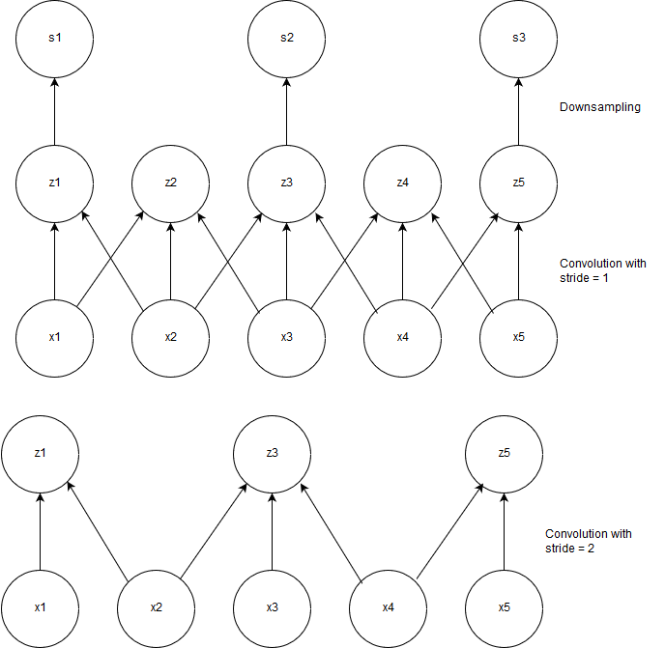

Figure 12: Illustration of mathematical equivalence of implementing a convolution with unit stride followed by downsampling to implementing a convolution with stride = 2.

Zero-padding is often applied to the input vector in order to prevent it from shrinking by one pixel less than the applied kernel width, i.e. for an input image of width m and kernel width k, the output of the convolution with no zero-padding will be m-k+1, a situation which would enforce smaller networks and smaller subsequent kernels if not accounted for, which in turn would limit the capacity of the network to find useful representations of the data [38].

Convolutions applied with no padding of the input image are known as valid convolutions, where pixels in the output of a convolution are a function of the same amount of pixels in the input, and the kernel can only be applied to positions on the image where the kernel is contained by the image [38].

When just enough zero-padding is applied to the input image to ensure that the output will be of the same dimensions, the convolution is known as a same convolution [38]. Although same convolutions do not limit the size of the network and allow one to build neural networks of arbitrary depth, they still result in pixels close to the edges of the image having less connections to the output image and therefore that their influence on the network as a whole will be reduced [38].

## Statistical Tests

### Hypotheses

Statistical tests are mathematical constructs designed to enable a researcher to make a measurable statement concerning to what extent observed data agrees with probabilistic predictions made about it in the form of a hypothesis [49].

When performing a statistical test, a null hypothesis, denoted as $H_{0}$, is put forth, as well as one or more alternative hypotheses, ($H_{1}$, $H_{2},…$).

Given a dataset of n measurements of a random variable $x= x_{1},…, x_{n}$, a set of hypotheses $H_{0},H_{1}$ are proposed, each specifying a joint probability density function (p.d.f.), i.e. $f\left(x | H_{0}\right), f\left(x | H_{1}\right),…$

In order to assess how well the observed data agrees with any given hypothesis, a test statistic $t(x)$, which is a function of the observed data, is constructed.

A specific p.d.f. for the test statistic, t, is implied by each of the hypotheses, i.e. $g\left(t | H_{0}\right), g\left(t | H_{1}\right),…$

While the test statistic can be a multidimensional vector $t=t_{1},t_{2},…, t_{m}$ (in principle, even the original vector of observed data points $x=x_{1},x_{2},…, x_{n}$ can be used), constructing a test statistic of lower dimension (where m < n) reduces the amount of data being assessed, without losing discriminative power.

If a scalar function $t(x)$ is used as the test statistic, a p.d.f. $g\left(t | H_{0}\right)$ is given which t will conform to when $H_{0}$ is true, similarly t will conform to a different p.d.f. $g\left(t | H_{1}\right)$ when $H_{1}$ is true. Figure 18 illustrates how setting a threshold value for the test statistic, i.e. $t_{cut}$, results in rejection of the null hypothesis when $t>t_{cut}$.



Figure 18: An illustration of rejection or acceptance of the null hypothesis, under the assumed distributions of $H_{0}$ and $H_{1}$, when t falls in the critical region $t>t_{cut}$

The support for various hypotheses under the observed data distribution is framed in terms of acceptance or rejection of the null hypothesis by defining a critical region for the test statistic, beyond which the null hypothesis is rejected; i.e. when the observed value of t lies within the critical region, we reject $H_{0}$. Conversely, when t lies within the complement of the critical region, it is said to be within the acceptance region, which will result in the researcher accepting $H_{0}$.

### Significance Level and Power

The critical region for rejection of the null hypothesis is defined by a cut-off point, such that the probability of t being observed there is defined by a value $α$, called the significance level of the test.

In the example shown in Figure 18, a critical region is defined by a value: $t_{cut}$, which defines the lower decision boundary for rejecting the null hypothesis.

The significance level defined as such is given by

$$α=\int_{t_{cut}}^{∞}{g\left(t | H_{0}\right)dt}$$

$H_{0}$ would not be rejected when ${t<t}_{cut}$, and there is a probability of $α$ of rejecting $H_{0}$ when $H_{0}$ is in fact true (called an error of the first kind), as well as a probability of accepting $H_{0}$ when $H_{1}$ was actually true. The probability of making an error of the second kind is given by

$$β=\int_{-∞}^{t_{cut}}{g\left(t | H_{1}\right)dt}$$

$1-β$ is called the power of the statistical test to discriminate against $H_{1}$.

### Statistical Tests for Particle Selection

In the case of electron-pion particle identification dealt with in this dissertation, we consider the class “electron” as signal and “pion” as background. As such, we define $H_{0}=e,{ H}_{1}=π$, and by extension, we treat the output of the final hidden unit in the neural network as a test statistic in its own right, lying either within a p.d.f. ${g(t|H}_{0})$ when it is an electron or $g(t|H_{1})$ when it is a pion. In order to accept or reject $H_{0}$, we define a critical region $t_{cut}$. When ${t≥t}_{cut}$, we classify the particle as an electron.

When looking at the probability of classifying a specific particle as a given type, we define the selection efficiencies, i.e. the electron efficiency $ε_{e}$ and pion efficiency $ε_{π}$ as follows:

$$ε_{e}=\int_{-∞}^{t_{cut}}{g\left(t | e\right)dt=1-α}$$

$$ε_{π}=\int_{-∞}^{t_{cut}}{g\left(t | π\right)dt=β}$$

This cut-off point can be chosen so as to accept as many electrons as possible, but the price paid for high electron efficiency is a large amount of pion contamination in the electron sample.

Based on the probability of a particle being an electron obtained from each of the 6 detector layers in the TRD, we use a Bayesian approach outlined in the formula below:

$$P\left(elec\right)=\frac{\prod_{j=1}^{6}{P_{j}(elec)}}{\sum_{k∈e,π}{\prod_{j=1}^{6}{P_{j}\left(k\right)}}}$$

Here, $P_{j}\left(elec\right)$ is the probability of the track being an electron obtained from layer $j$.

## Stage 2 of Model Building: Testing a Large Variety of Architectures and Hyperparameter settings

Various deep neural network architectures were developed towards particle identification, using Keras with a Tensorflow back-end.

The following repositories host the code used to build and train feedforward-, convolutional- and LSTM neural networks towards particle identification:

<https://github.com/PsycheShaman/msc-hpc>

<https://github.com/PsycheShaman/hpc-mini>

<https://github.com/PsycheShaman/MSc-thesis>

A summary of the input tensors used for the various types of deep learning architectures mentioned above is as follows:

* Feed-forward neural networks were fed with summarised data, i.e. the original $n×17×24$ matrices were collapsed down to 17 row-sums and 24 column-sums, to arrive at a wide input matrix with dimensions $n×41$. Some networks were also trained with additional hand-designed features
* 2D convolutional neural networks were fed data with one image channel added to the $n×17 ×$ 24 matrices, to produce an input tensor of dimensions $n×17×24×1$
* 1D convolutional neural networks were fed data with one channel added to the 24 column-sums, to produce an input matrix of $n×24×1$
* LSTM neural networks were fed data where the $n×17 ×$ 24 matrices were transposed to have dimensions $n×24×17$, i.e. 24 time-bins with 17 features

During this stage of model building, class imbalances were accounted for by downsampling the pion sample to be equal in size to the electron sample.

Data was normalized as follows:

$$x=\frac{x-max⁡(x)}{max⁡(x)}$$

The SLURM-managed High-Performance Computing Cluster at UCT was utilized extensively to test the performance of various deep learning architectures, enabling one to train various deep learning models in parallel.

Over the next few pages, an assessment of the usefulness of various model architectures and hyperparameter settings developed during this stage is conducted at the hand of plots.

### 2D Convolutional Neural Networks

All 2D Convolutional Neural Networks developed for Particle Identification are summarised in Figure 42, Figure 43, Figure 44, Figure 45 and Figure 46.

Although it is quite difficult to make any absolute statements about which model architecture is best suited to this problem, there are some conclusions that can be drawn from the plots below.

It is immediately apparent from Figure 42 that the worst-performing models were all trained with a fairly high learning rate. These models were also trained with different optimizers compared to better-performing models, but this is confounded with the fact that the Adam optimizer started being used at the same time that the learning rate was reduced. Using the correct learning rate is essential, since using a very high learning rate will result in the gradient descent algorithm jumping over possible minima, whereas a learning rate which is too low will struggle to converge and might get stuck in local minima.

50-100 epochs seem to be enough iterations to train decently performing models, but the more important aspect to monitor is whether training loss and validation loss start to diverge, which indicates that the model is starting to overfit to the training set. It is hard to monitor this aspect when training on a server, but this can be achieved by piping the output of the Python script used for training to a text file, setting the Keras training verbosity to level 2 and monitoring the model’s progress by calling the tail -F out.txt bash command. As a general rule of thumb, training models on this dataset for more than 100 epochs is not useful and will most likely result in overfitting. In terms of computational cost, when running Convolutional Networks on the full dataset for 100 epochs, training time can take up to 2-3 days.

From Figure 42, one can see that is is difficult to establish a clear guideline as to the number of layers (convolutional- or dense), which will result in a low pion efficiency at high electron efficiency. Models with a total of 8-9 layers seem to perform well in general and models with 6 or less layers slightly worse, although the model which gave the second-best performance only had a total of 4 layers, of which two were convolutional.

Using larger kernel sizes seems to be a good strategy, judging by the top two best-performing models, who both had 8x12 and 5x6 kernels in the first two layers of the network. The best-performing model was one of only two models that had 4 convolutional layers, the other model with this much convolutional depth being in the top 4 highest-performing models as well.

There is no consistent indication of whether using Max Pooling improved performance in this task, but the top two models did not make use of them.

Figure 44 shows that most 2D Convolutional models were trained with a batch size of 32, while using a smaller batch size makes gradient updates slightly more volatile and therefore a little less accurate, using very large batch sizes makes this already computationally expensive procedure take even longer.

While a lot of time was spent on building different architectures, comparatively little time was spent on optimizing hyperparameters, such as learning rate, batch size, dropout rate, weight initialization strategies and testing different standard deviation settings with Gaussian Noise layers.

In retrospect, spending some time on setting up Randomized Grid Searches could have been useful, but this brings us to the point of why pion rejection results in this thesis are not comparable to previous work done on Particle Identification.

The data used in this project was not corrected for chamber gain, nor was pad-by-pad calibration performed on the raw dataset. These two essential steps explain the hard limit on accuracy/ pion efficiency, which seems to be at around 75% accuracy an 1-2% pion efficiency; therefore spending even more time on this phase of the project would be futile, since results on raw data will never compare with results from models trained on properly calibrated data.

A surprising result from Figure 45 is that Dropout was not employed in the model which achieved the lowest pion efficiency score. It is difficult to explain why this is the case, since Dropout should generally enable a model to achieve higher accuracy on unseen data. However, by looking at the training and validation accuracy and loss curves in Figure 59 and Figure 60, one sees that this model did indeed not overfit, despite it not being regularised. Perhaps the large capacity of this network compensated for the lack of regularisation, or perhaps this model just happened to pick up features that generalised well on unseen data by random statistical fluctuations.



Figure 42

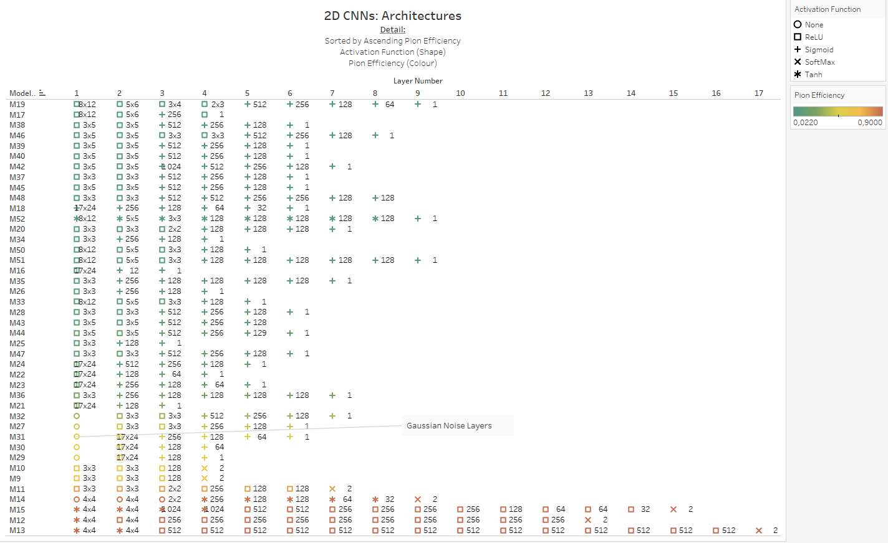

Figure 43

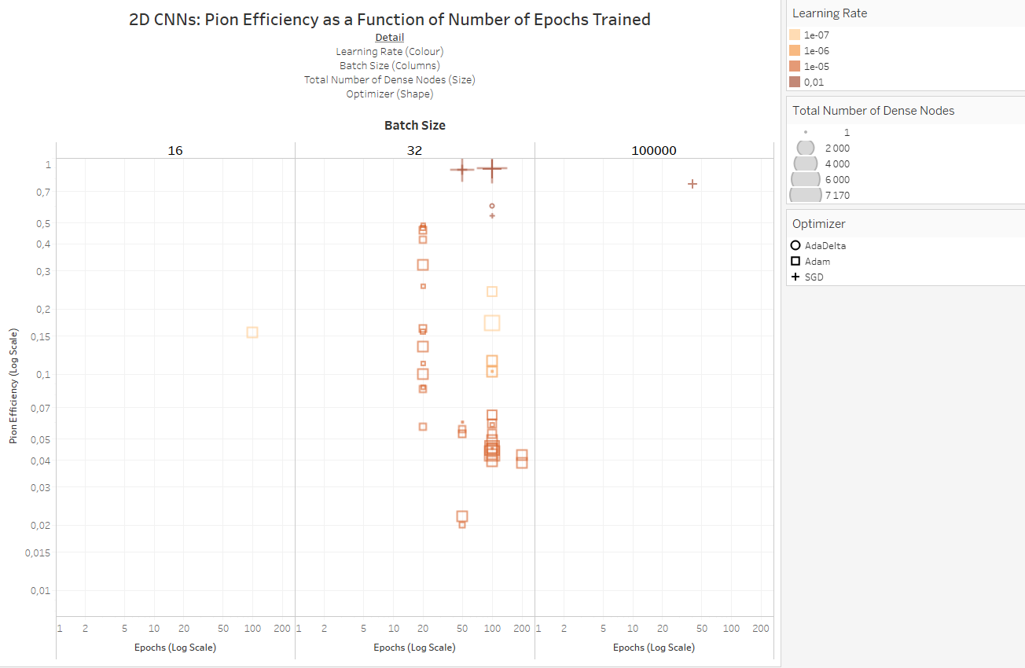

Figure 44

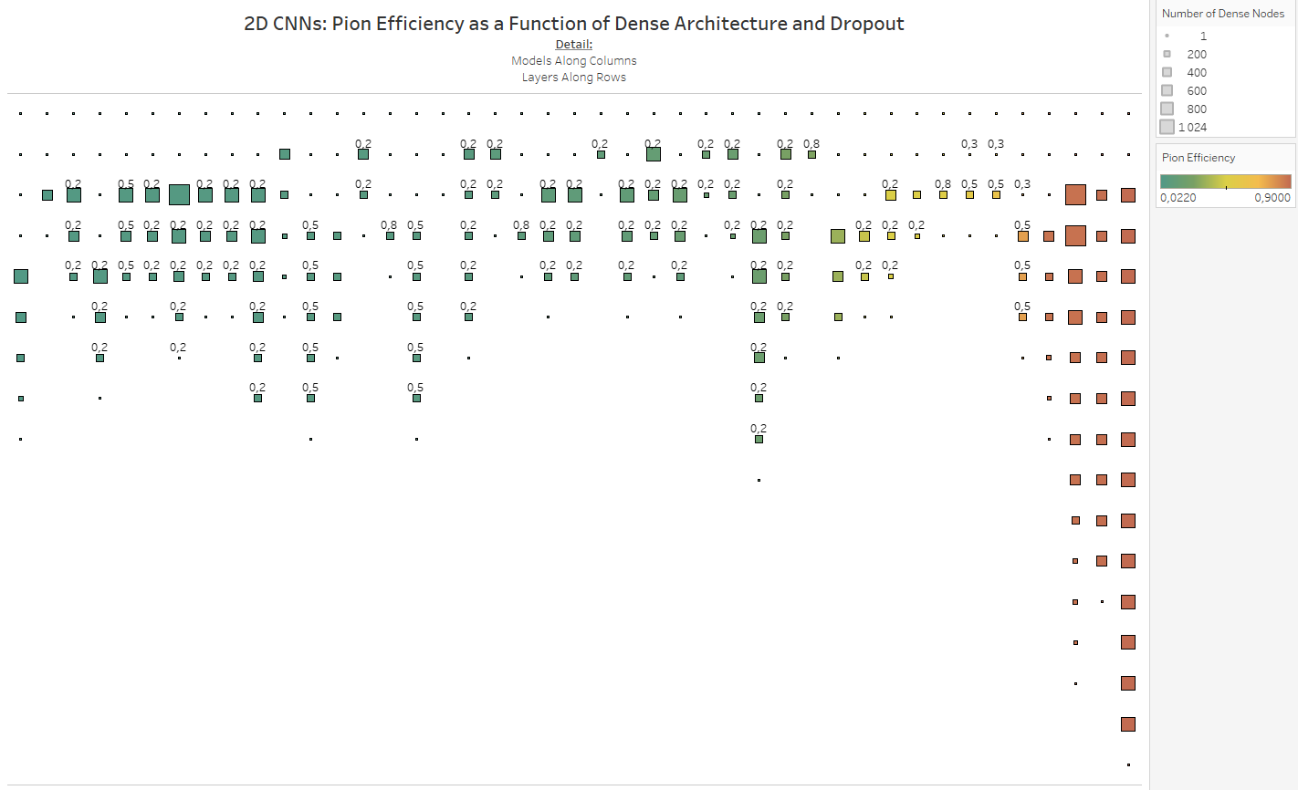

Figure 45

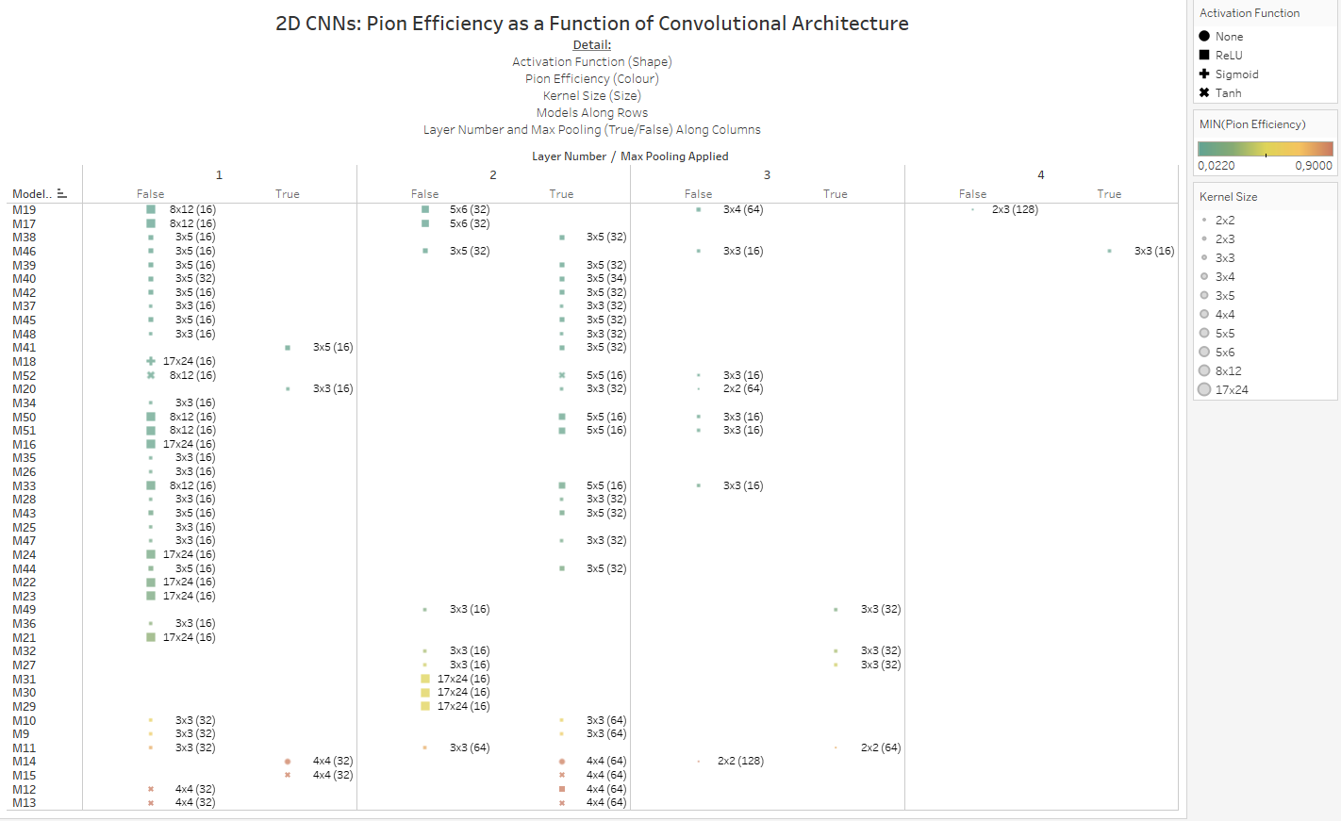

Figure 46

### Discussion of Most Successful Model from Stage Two of Model Building

At the conclusion of the second stage of model building, the following 2D convolutional neural network architecture (Figure 58) achieved the lowest pion efficiency $ε_{π}=2.2\%$ at electron efficiency $ε_{e^{ }}=90\%$:

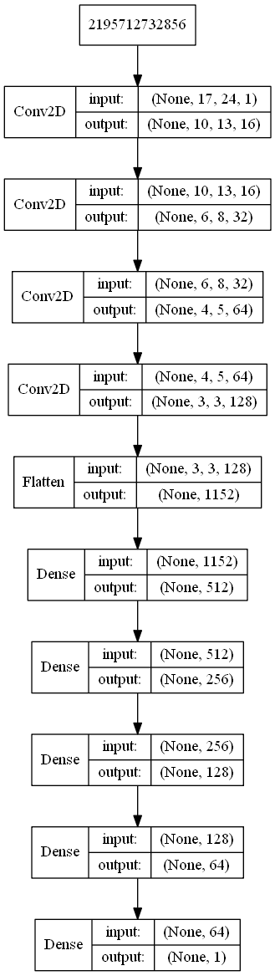

Figure 58: Particle Identification Model Architecture

Using the Adam optimizer with learning rate = 0.00001, trained for 100 epochs with a batch size of 32, using binary cross-entropy as the loss function to be optimized.

The training and validation accuracy and loss graphs for this model are depicted below.

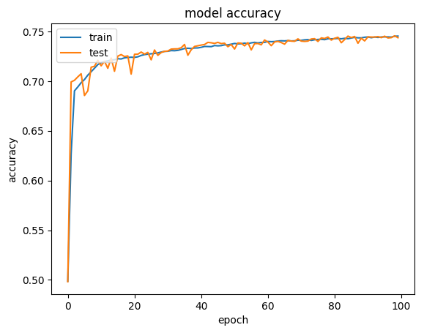

Figure 59: Training vs Validation Accuracy

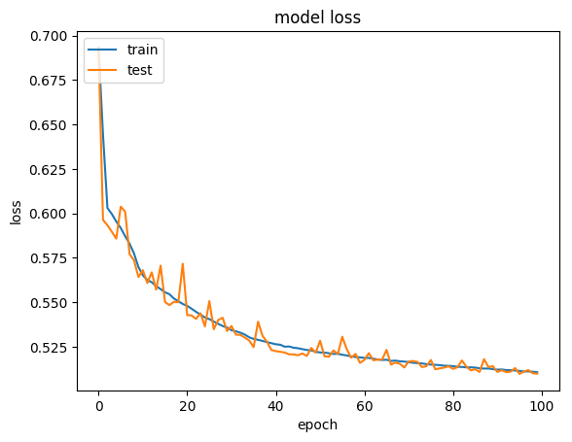

Figure 60: Training vs Validation Loss

Pion efficiency at 90% electron efficiency was calculated by writing a function which, when minimized, finds the cut-off point (critical region) in the distribution of the single node output layer which results in 90% of true electrons being classified as electrons, on a per-tracklet basis. This was done for tracks which left signal in all 6 layers of the TRD, allowing one to construct a test statistic taking all 6 estimates for the track into account, as outlined in 5.3 Statistical Tests for Particle Selection.

The result of the minimization process is shown in Figure 61: any track which receives a combined probability above $t_{cut}$ (shown as a vertical red line) was classified as an electron, otherwise it was classified as a pion.

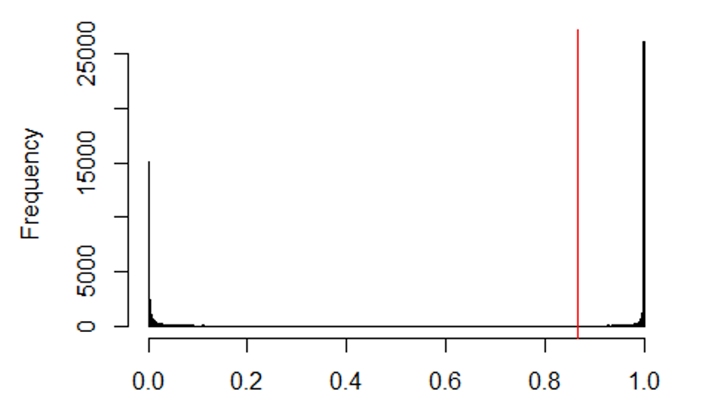

Figure 61: t-statistic selection allowing for 90% electron efficiency

After applying the classification based on $t_{cut}$, the histograms for the 6-tracklet estimate, for both electrons and pions is shown below:

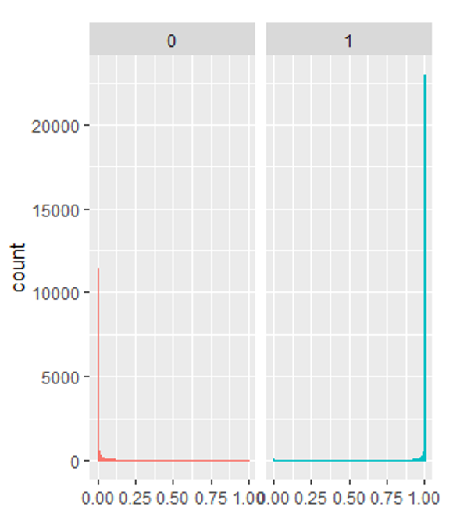

Figure 62: Combined output probabilities for true electrons (1, blue) and true pions (0, red)

Table 2 shows the obtained confusion matrix, with predicted labels along the rows and actual labels along the columns, here the diagonal of the confusion matrix are particles that were classified correctly:

Table 2: Confusion Matrix for Particle Identification

|  |  |  |
| --- | --- | --- |
| Prediction/Actual | 0 | 1 |
| 0 | 47 833 | 4 893 |
| 1 | 1 088 | 44 028 |

### Summary of Most Successful Models, per Model Type

#### 2D Convolutional Neural Networks

$ε_{π}=2.2\%$ at electron efficiency $ε_{e^{-}}=90\%$

#### 1D Convolutional Neural Networks

$ε_{π}=6.55\%$ at electron efficiency $ε_{e^{-}}=90\%$

#### Fully Connected Feedforward Neural Networks

$ε_{π}=14.86\%$ at electron efficiency $ε_{e^{-}}=89.99\%$

#### LSTM Neural Networks

$ε_{π}=5.3\%$ at electron efficiency $ε_{e^{-}}=90\%$

#### Non-Deep Learning (Tree Based) Models

The effectiveness of two non-deep learning models, Random Forests and Gradient Boosting Machines, were also tested with 17 rowsums and 24 column sums (with column-wise centering and scaling applied) as features, using H2O.ai, at default settings for both model types. The results were as follows:

##### Random Forests

$ε_{π}=5.8\%$ at electron efficiency $ε_{e^{ }}=90\%$

##### Gradient Boosting Machines

$ε_{π}=6.59\%$ at electron efficiency $ε_{e^{ }}=89.99\%$

## Stage 3 of Model Building: Focal Loss, Incremental Training per Momentum Bin

During the final stage of model building, a different approach was taken, in order to compare particle identification results to work done before.

### Data pre-processing

* The full dataset was used during this stage.
* All tracklets with no signal, i.e. images where all the pixel values were zero, were removed.
* Data was not normalised or standardised.
* Data was not down-sampled or up-sampled to account for class imbalances.
* Data was split into the following momentum bins:

$$P≤2 GeV,$$

$$2 GeV<P≤3 GeV,$$

$$3 GeV<P≤4 GeV,$$

$$4 GeV<P≤5 GeV,$$

$$5 GeV<P≤6 GeV$$

### Accounting for Class Imbalance without resorting to down-sampling: Custom Focal Loss Function

Focal Loss was proposed by [50] as a loss function which down-weights the importance of well-classified examples, effectively making training examples that are more difficult to classify contribute more to the overall loss. This is useful in cases, such as this project, where one class dominates the class distribution and therefore becomes favoured during prediction, since favouring the dominant class results in a low overall loss.

Focal loss is not a default loss function in Keras, but has been implemented by [51] for Python. The author subsequently adapted this for use in Keras with R [52], since no equivalent custom focal loss implementation could be found online for R.

Figure 67 shows how the Focal loss function decreases steeply as classification probability approaches the true class level. This loss function allowed for building models on a dataset with imbalanced classes, without having to resort to down-sampling or up-sampling and therefore made it possible to use a much larger training dataset, the combination of these two factors probably played the biggest part in the very low pion efficiencies obtained with this approach, during the final stage of model building.



Figure 67: Focal Loss where true class is 1.

### Incremental Model Training, per Momentum-bin

Keras allows one to resume training of a model, by increasing the number of epochs in the keras::fit() function to the total number of desired epochs, i.e. number of epochs (previous training round) + additional epochs to be run, and specifying an initial_epochs argument, which should be the final epoch number from the previous training round.

Using this functionality, a 2D Convolutional Network was trained on particles in the $P≤2GeV$ range for 10 epochs (note that the class imbalance at this momentum range is less pronounced, containing a ratio of around 76 pions: 24 electrons), Figure 68 shows the accuracy and loss curves obtained.

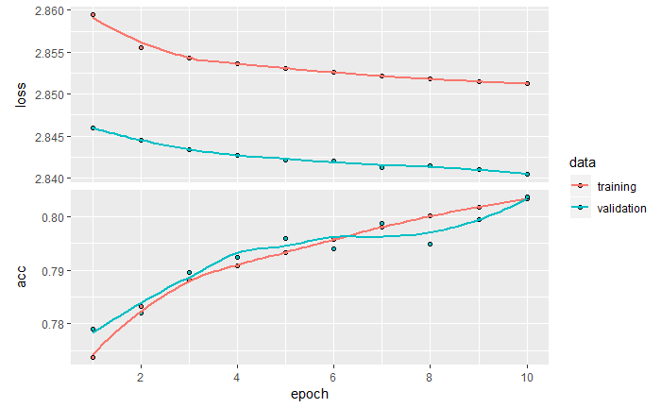

Figure 68

When it became clear that the model was not yet overfitting, but had some statistical power (validation accuracy $\sim 80\%$ compared to what a majority class classifier would give, i.e. $\sim 76\%$), the model was trained for an additional 20 epochs (Figure 69).

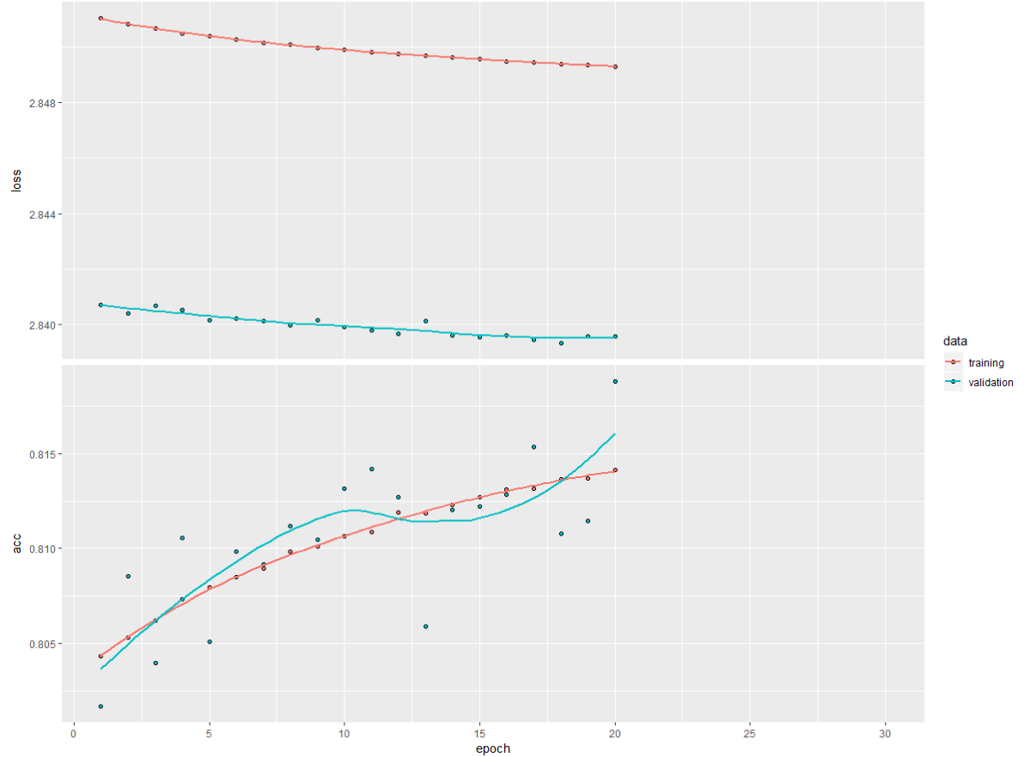

Figure 69

This model performed as follows on an independent test set of particles in the same momentum range that it was trained on:

$ε_{π}=1.2\%$ at $ε_{e}=89.99\%$, which is much better than anything obtained during the second stage of model building.

Surprisingly, this model performed almost equally well on particles in the following momentum bin, i.e. performance on particles with momenta $2 GeV<P≤3GeV$ was $ε_{π}=1.4\%$ at $ε_{e}=90\%$.

Another feature of Keras is that the state of the optimizer of a saved model can be discarded and only the weights of a previously trained model can be loaded into a new model with the same architecture. Using this functionality training was continued, using the pretrained model, on particles in the $2 GeV<P≤3GeV$ range (Figure 70).

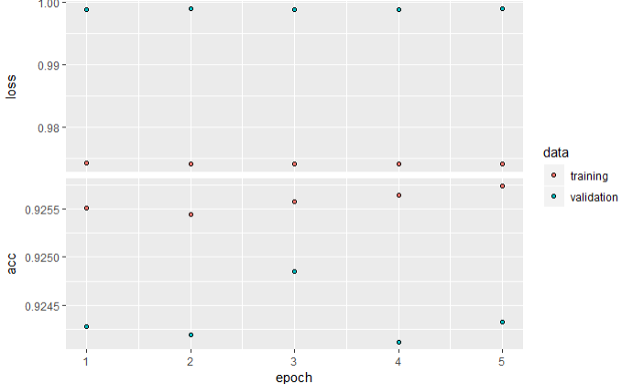

Figure 70

When evaluated on a test set in this momentum range ($2 GeV<P≤3GeV$), performance increased slightly to $ε_{π}=1.14\%$ at $ε_{e}=89.99\%$

And when tested on particles in the next momentum range ($3 GeV<P≤4GeV$), performance remained surprisingly high: $ε_{π}=1.16\%$ at $ε_{e}=89.86\%$.

This model was then trained for a further 5 epochs on particles in the $3 GeV<P≤4 GeV$ range (Figure 71)

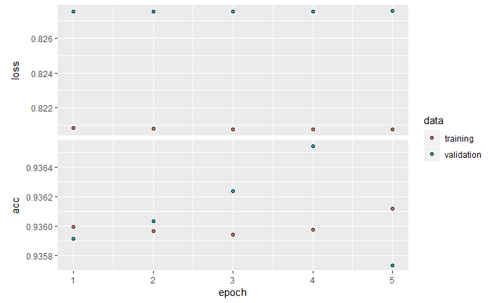

Figure 71

Performance actually decreased when tested on particles in the $3 GeV<P≤4 GeV$ range, to $ε_{π}=1.51\%$ at electron efficiency $ε_{e^{-}}=89.99\%$. This might be explained by the fact that there is a much smaller proportion of electrons in this momentum range than in the lower GeV ranges. Additionally, when tested on particles in the next momentum range, the model’s generalizability breaks down and predicts “pion” everywhere.

Table 3

|  |  |  |
| --- | --- | --- |
| Prediction/Actual | 0 | 1 |
| 0 | 36713 | 2359 |
| 1 | 0 | 0 |

Pion efficiency at 90 % electron efficiency cannot be calculated here, since the optimization algorithm for finding $t_{cut}$ does not converge, because the distribution of the combined probability that a particle is an electron is very narrow, close to zero.

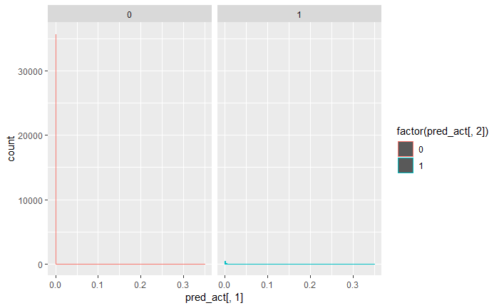

i.e. we arrive at $ε_{π}=0\%$ at $ε_{e}=0\%$

The incrementally trained model, which at this stage has already become extremely biased towards predicting pion with a very high certainty, was then trained on particles in the $4 GeV<P≤5 GeV$ range (Figure 72).

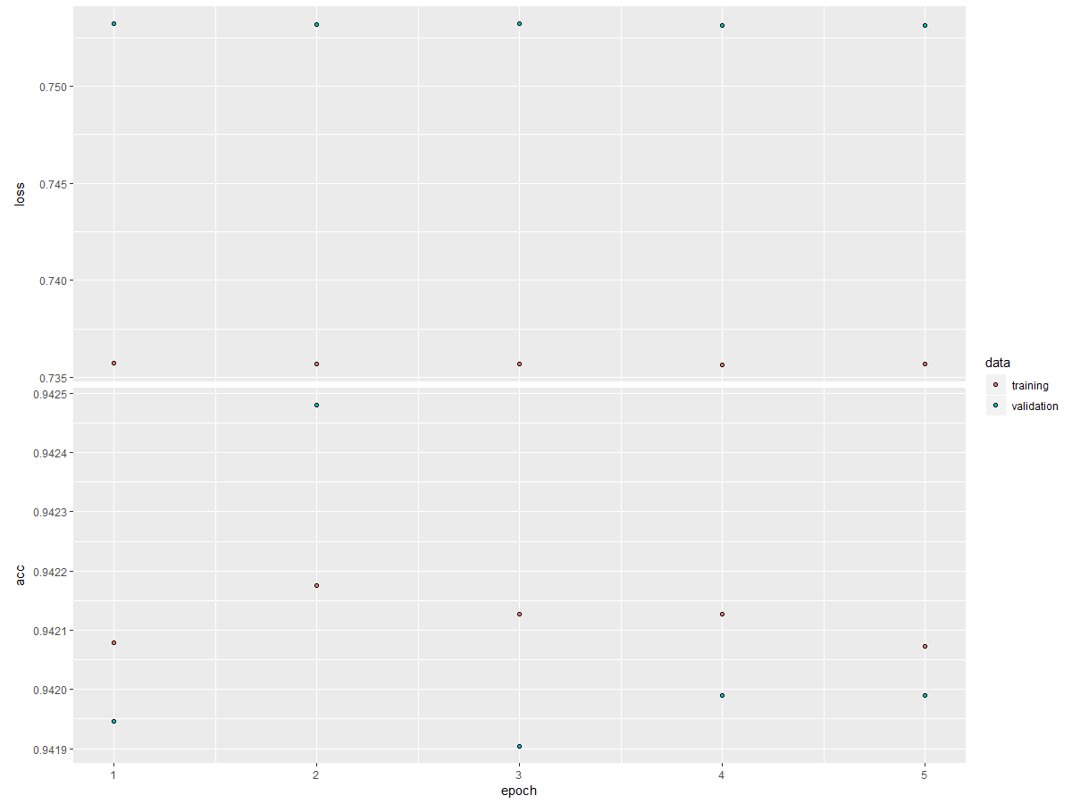

Figure 72

The incrementally trained model seems to increase in accuracy, but only because, at this stage of training, it has seen a lot more pions than electrons, and the focal loss function is no longer able to mitigate the extreme class imbalance. There is no change in the confusion matrix, reported above, prior to training for additional epochs in this high GeV range.

The model was not trained for particles in the $5 GeV<P≤6 GeV$ range as a separate training set, since it had already started to overfit (beyond rescue) to the imbalanced class distribution.

Figure 73 summarises the results from the final stage of model-building, in order to allow for comparison with work that had been done in the past on particle identification using the TRD (for that reason Figure 74, which was also shown in Section 7.1.1.2 is repeated here for comparison).

Figure 73: Summary of incrementally trained (with uncalibrated dataset, partitioned by increasing momentum range) Convolutional Neural Network



Figure 74: Summary of previous work done on Particle Identification using calibrated data from the TRD

Again, it needs to be stressed that the poorer performance of particle identification obtained during this project is most probably fully accounted for by the quality of data was used here, in comparison to pad-by-pad calibrated data fed to much simpler neural fully connected neural networks in the previous work done.

An interesting fact about the results obtained during the final stage of model building is the fact that the data it was trained on was not scaled in any way. Perhaps this was also a contributing factor to the low pion efficiencies obtained, possibly because the signal arrays are very sparse, with most pixels being equal to zero, allowing the gradients during backpropagation to flow more strongly when the other pixels are also close to zero, but this is just speculation. For the most part, neural networks remain proverbial black boxes.

# High Energy Physics Event Simulations

## Generative Models

Generative models are concerned with modelling potentially high-dimensional distributions. Dependencies between various random variables in the multidimensional distribution can also be captured during this modelling process [42].

Generative models are concerned with generating data that is similar to seen data, but not exactly the same, i.e. our training examples $X$ are distributed according to some unknown distribution $P_{gt}(X)$ and we want to model a distribution $P$ which is as similar as possible to $P_{gt}$ and therefore allows us to generate new examples $X$ by sampling from $P$ [42].

Neural networks can be utilised as function approximators towards constructing a modelled distribution $P$ as outlined above [42].

### Background: Latent Variable Models

When there are complex dependencies between the dimensions of the data, generative models become very hard to train. Latent variables are samples drawn from specific latent distributions constructed during training, before the generative process commences, i.e. the model first chooses what it is going to simulate before it starts simulating [42].

In order to deduce that a generative model is representative, one needs to find that for each datapoint $X$ in $χ$, there are one or more latent variable settings which result in the model generating something sufficiently similar to $X$ [42].

A vector of latent variables $z$, are sampled from a high dimensional latent space $Z$, according to a probability density function (p.d.f.): $P(z)$ defined over $Z$. A group of deterministic functions $f(z;θ)$ parameterized by a vector $θ$ in some space $Θ$, with $f:Z×Θ→χ$. While $f$ is deterministic, $z$ is randomly sampled and $θ$ is fixed, which makes $f(z;θ)$ a random variable in the space $χ$. $θ$ needs to be optimized so that sampling $z$ from $P(z)$ will result in a high probability of $f(z;θ)$ outputting data similar to the training data $X$ [42].

More formally, we want to maximize the probability of each $X$, according to:

$$P\left(X\right)=\int{P\left(X | z;θ \right)P\left(z\right)dz}$$

$f(z;θ)$ has been changed to a distribution $P\left(X | z;θ \right)$ in the expression above, in order to show explicitly that $X$ depends on $z$. Maximum Likelihood underpins the notion that if $X$ is likely to be reproduced, generated examples that are highly similar to $X$ are also likely to be produced, and dissimilar examples are unlikely [42].

VAEs often model the output distribution as a Gaussian, $P\left(X | z;θ \right)=N(X|f\left(z;θ\right),σ^{2}*I)$, i.e. the distribution has mean $f(z;θ)$ and covariance equal to some scalar $σ$ multiplied by the identity matrix $I$, with $σ$ being a tuneable hyperparameter [42].

A VAE will in general not produce examples identical to any $X$, especially not during early training, but under the Gaussian assumption, $P(X)$ can be increased via gradient descent by making $f(z;θ)$ approach $X$ given some $z$ [42].

### Variational Autoencoders

Variational Autoencoders (VAEs) aim to maximize $P\left(X\right)=\int{P\left(X | z;θ \right)P\left(z\right)dz}$ by defining latent variables $z$ and integrating over $z$. Choosing the latent variables $z$ are not trivial, since $z$ is generally not just defined by the label of the example that needs to be generated, but by other features specific to the example [42], in our case, $z$ would not just be electron or pion, but additional dimensions such as the particle’s momentum, angle, etc. Generally, a researcher would not explicitly specify what the dimensions of $z$ specify, nor how the dimensions of $z$ depend on one another [42].

In VAEs, $z$ is drawn from a distribution $N(0,I)$, where I is the identity matrix, since any distribution in $d$ dimensions can be generated by sampling from $d$ normally distributed variables and mapping them through a function with high enough capacity to generate $X$. When $f(z;θ)$ is a neural network then the initial layers will be involved in generating $z$ while the later layers will be concerned with mapping $z$ to $X$; $P(X)$ will be maximized by finding a computable formula for it, taking its gradient at each epoch and optimizing it using stochastic gradient ascent [42].

$P\left(X\right)$ can be computed approximately by sampling $z$ values repeatedly $z=\{z_{1},z_{2},…,z_{n}\}$ and computing $P(X)≈\frac{1}{n}\sum_{i}{P(X|z_{i})}$, in high dimensional spaces, $n$ might have to be very large before $P(X)$ can be accurately approximated [42].

For most $z$, $P(X|z)$ will be close to zero, but in order for the VAE to be useful, we need to sample $z$ values that are likely to have resulted in $X$ and sample only from that subset, a new function $Q(z|X)$ is needed to take an existing $X$ value and calculate a distribution of $z$ values that could have realistically resulted in $X$ being generated; this narrows the universe of $z$ values down from the larger universe of all $z's$ likely under the prior $P(z)$ [42].

How $E_{Z\sim Q}P(X|z)$ and $P(X)$ are related is one of the basic tenets upon which variational Bayesian methods are built. The Kullback-Leibler divergence ($D$) between $P(z|X)$ and $Q(z)$ for an arbitrary $Q$ which does not necessarily have to depend on $X$, is given by:

$$D[Q(z)|\left|P\left(z | X\right)\right]=E_{Z\sim Q}[\log{Q\left(z\right)}-\log{P(z|X)}]$$

$P(X)$ and $P(X|z)$ can be added to this equation by applying Bayes rule:

$$D[Q(z)|\left|P\left(z | X\right)\right]=E_{Z\sim Q}\left[\log{Q\left(z\right)}-\log{P\left(z | X\right)}-\log{P\left(z\right)}\right]+\log{P(X)}$$

Since $\log{P(X)}$ does not depend on $z$, it appears outside the expectation. Rearrangement of this formula, negation and contraction of part of $E_{z\sim Q}$ into a KL-divergence term gives us:

$$\log{P\left(X\right)-}D[Q(z)|\left|P\left(z | X\right)\right]=E_{Z\sim Q}\left[\log{P\left(X|z\right)}\right]-D[Q(z)||P(z)]$$

In the above equation, $X$ is fixed and $Q$ can be any distribution, regardless of whether it accurately maps $X$ to $z's$ that could have produced $X$, but in our case we are interested in accurately inferring $P(X)$ and therefore we want to find a $Q$ which does depend on $X$ and which also keeps $D[Q(z)|\left|P\left(z | X\right)\right]$ as small as possible:

$$\log{P\left(X\right)-}D[Q(z|X)|\left|P\left(z | X\right)\right]=E_{Z\sim Q}\left[\log{P\left(X|z\right)}\right]-D[Q(z|X)||P(z)]$$

The formula above is the central formula of the VAE, the left hand side is what needs to be maximized: $P(X)$, penalized by $-D[Q(z|X)||P\left(z | X\right)]$, which will be minimized if $Q$ is a high capacity distribution which produces $z$ values that are likely to reproduce $X$, the right hand side is differentiable and can therefore be optimized using gradient descent.

When looking at the above equation, the right hand side takes the form of an autoencoder, where $Q$ encodes $X$ into latent variables $z$ and P decodes these latent variables to reconstruct $X$.

On the left side of the equation, $\log{P(X)}$ is being maximized while $D[Q(z|X)||P\left(z | X\right)]$ is being minimized. While $P(z|X)$ is not analytically solvable and simply describes $z$ values likely to reproduce $X$, the second term in the KL-divergence on the left is forcing $Q(z|X)$ to be as similar as possible to $P(z|X)$, and under a model with sufficient capacity $Q(z|X)$ should be able to be exactly the same as $P(z|X)$, which will result in $D$ being zero and the direct minimization of $\log{P(X)}$, in addition $P(z|X)$ is no longer intractable since $Q(z|X)$ can be used to solve for it.

In order to minimize the right hand side of the above equation via gradient descent, $Q(z|X)$ will usually take the form:

$$Q\left(z | X\right)=N(z|μ\left(X;ϑ\right),Σ\left(X;ϑ\right))$$

Where $μ$ and $Σ$ are deterministic functions with learnt parameters $ϑ$; in practice $μ$ and $Σ$ are learnt via neural networks and $Σ$ is constrained to a diagonal matrix format. $D[Q(z|X)||P\left(z\right)]$ therefore becomes a KL-divergence between two multivariate Gaussians, computed in closed form as:

$$D[N(μ_{0},Σ_{0})|\left|N\left(μ_{1},Σ_{1}\right)\right]= \frac{1}{2}(tr\left(Σ_{1}^{-1}Σ_{0}\right)+{\left(μ_{1}-μ_{0}\right)}^{⊺}Σ^{-1}\left(μ_{1}-μ_{0}\right)-k+\log{(\frac{detΣ_{1}}{detΣ_{0}})}$$

With k indicating the number of dimensions of the distribution; this can be simplified to become:

$$D[N(μ\left(X\right),Σ(X))|\left|N\left(0,I\right)\right]=\frac{1}{2}(tr\left(Σ\left(X\right)\right)+{\left(μ\left(X\right)\right)}^{⊺}\left(μ\left(X\right)\right)-k-\log{det⁡(Σ(X))})$$

The other term on the right hand side of the equation, $E_{Z\sim Q}\left[\log{P\left(X|z\right)}\right]$, can be estimated by taking a sample from $z$ and calculating $P(X|z)$ for that single sample to approximate $E_{Z\sim Q}\left[\log{P\left(X|z\right)}\right]$.

Since we are doing stochastic gradient descent over different $X$ values from our dataset $D$, we want to perform gradient descent on the following formula:

$$E_{X\sim D}[\log{P\left(X\right)}-D\left[Q\left(z | X\right) | \left|P\left(z | X\right)\right]\right]=E_{X\sim D}[E_{Z\sim Q}\left[\log{P\left(X | z\right)}\right]-D[Q(z|X)||P(z)]]$$

By sampling a single value of $X$ and a single value of $z$, we can compute the gradient of $\log{P\left(X | z\right)-D[Q(z|X)||P(z)]}$, which when averaged over multiple samples, converges to the full equation to be optimized.

The issue here is that $E_{Z\sim Q}[\log{P(X|z)}]$ does not only depend on the parameters of $P$, but also those of $Q$, but this is not accounted for in the above equation. For VAEs to work properly, $Q$ needs to be driven to produce $z's$ from $X$ that are likely to be reliably decoded by $P$.

Figure 13 illustrates how this proxy formula can be used by averaging over multiple samples to get to the expected outcome, but since there is a sampling procedure embedded within the neural network, gradient descent cannot be performed on it.

Figure 14, on the other hand, shows how a “reparameterization trick” removes he sampling procedure from the neural network proper and treats it as an input layer. Since we have $μ(X)$ and $Σ(X)$, we can sample $ϵ$ from $N(0,I)$ and compute $z$ from $ϵ$ as follows: $z=μ\left(X\right)+Σ^{\frac{1}{2}}\left(X\right)*ϵ$.

As a result, the gradient of the following equation will actually be taken:

$$E_{X\sim D}\left[E_{ϵ\sim N\left(0,I\right)}\left[\log{P\left(X | z=μ\left(X\right)+Σ^{\frac{1}{2}}\left(X\right)*ϵ\right)}\right]-D[Q(z|X)||P(z)]\right]$$



Figure 13: Training-time VAE



Figure 14: Training-time VAE with reparameterization trick to enable backpropagation



Figure 15: Testing time VAE

Once the model is ready to be tested, values from $z\sim N(0,I)$ are sampled and fed to the decoder; the encoder, along with the attendant reparameterization trick used during training are thrown away.

### Generative Adversarial Networks

Generative Adversarial Networks (GANs) are a deep learning framework which pits two neural networks against each other in an adversarial mini-max game: the generative model $G$ is trained to the point where it accurately captures the distribution of the training data, and the discriminative network $D$ takes the output of $G$ and estimates the probability of whether $G$’s output originated from the actual data distribution or from a model distribution [43].

The mini-max game can be expressed mathematically as:

$$\min_{G}{\max_{D}{V\left(D,G\right)=E_{x\sim p_{data}\left(x\right)}\left[\log{D\left(x\right)}\right]+E_{z\sim p_{z}(z)}[\log\left(1-D\left(G\left(z\right)\right)\right))]}}$$

Essentially, the objective is to maximize the probability of $D$ assigning the correct label to samples from $G$, i.e. is a given observation from the “data”- or “model” distribution, while training $G$ to minimize $\log\left(1-D\left(G\left(z\right)\right)\right)$, i.e. we want $G$ to produce samples that are hard to discriminate from samples from the true data distribution.

This is done by sampling from a random noise vector $z$, with a defined prior $p_{z}(z)$ and learning a transformation from the noise vector to a distribution which is highly similar (preferably identical) to the true data distribution; in practice, this transforming function is the generative network $G(z,θ_{g})$, with $θ_{g}$ being the parameters of a deep neural network which maps $z$ to data space.

In practice, the training algorithm will alternately optimize $D$ for $k$ steps and $G$ for a single step, which allows $D$ to remain close to its optimum if $G$ does not change too rapidly, this also allows for the algorithm to run computationally more efficiently and prevents overfitting. During the early stages of training, it will be quite easy for $D$ to discriminate between data and model samples, since $G$ will still be learning to output more realistic samples, therefore $G$’s objective function $\log\left(1-D\left(G\left(z\right)\right)\right)$ will saturate, so an alternative objective function $\log{D\left(G\left(z\right)\right)}$ is maximized in practice by $G$, which does not change the dynamics of $D$ and $G$ much but allows for gradients that are sufficiently large to perform useful stochastic gradient descent.



Figure 16: Gan Densities during training, close to convergence, P(x) is shown in black, G(z) in blue and D(G(z)) in red



Figure 17: Gan Densities during training, once the Algorithm has converged, G(z) matches P(x) perfectly and D(G(z)) outputs 0.5 everywhere

### Variations on the GAN concept used towards Event Simulation in this Dissertation

#### Auxiliary Classifier Generative Adversarial Network

Auxiliary Classifier Generative Adversarial Networks enforce class label conditioned synthesis models, i.e. by feeding a GAN the class label of an image $c \sim p_{c}$, $G$ is now a function of both a noise vector and the label of the image, i.e. $G(z,c)$, whereas $D$ is not only tasked with classifying whether data is real or simulated, but also the class label of the image. This process has been shown to stabilize training [44].

#### Adversarial Autoencoder

Adversarial Autoencoders match the aggregated posterior of the latent space vector from an autoencoder $q\left(z\right)=\int_{x}^{ }{q\left(z | x\right)p_{d}\left(x\right)dx}$ with an arbitrary prior distribution $p(z)$, a process which results in meaningful samples being generated from any sample from any part of the prior space. The decoder function learns a function to map from the imposed prior distribution to the data distribution. In this set-up, the generator of the GAN also acts as the encoder function of the autoencoder, a process which assists the generator in fooling the discriminator of the GAN into misclassifying simulated data as real data [45].

#### Bidirectional Generative Adversarial Network

Bidirectional Generative Adversarial Networks (BiGANs) make use of an encoder function which maps data $x$ into a latent feature space $z$ for the generative model, i.e.: $E:Ω_{x}⟶Ω_{z}$. Here the discriminator has access to both the (simulated or real) $x$, as well as its latent encoding $z$ when classifying samples as real or simulated. In this way, BiGANs not only learn how to map from a latent space to data, but how to perform the inverse mapping, i.e. data to latent space [46].

#### Deep Convolutional Generative Adversarial Network

Deep Convolutional Generative Adversarial Networks make use of fully convolutional neural networks for both the generator and discriminator, using strided convolutions to allow these networks to learn their own spatial downsampling in the case of the discriminator and spatial upsampling in the case of the generator. These models also make use of Batch Normalization, which ensures that the input to any hidden unit has zero mean and a variance of 1, a process which compensates for poor initialization strategies, helps with the flow of gradients through complex models and preventing the generator from outputting similar simulated images from any sample of the noise space, a common issue which plagues GANs [47].

#### Least Squares Generative Adversarial Network

Whereas regular GANs use the sigmoid cross entropy loss function, which results in vanishing gradients when samples are generated that are classified as real data, but that are still far from looking like real data, Least Squares Generative Adversarial Networks (LSGANs) use an adaptation of the least squares loss function for the discriminator network, which has been shown to result in images of higher quality and result in networks that are more stable during training [48].

## Deep Learning for Distinguishing Geant4 data from real data

### Geant4 Configuration and Simulation

Geant4 simulations were configured using <https://github.com/PsycheShaman/trdpid/blob/master/sim/Config.C> , simulations were run as per the following shell script: <https://github.com/PsycheShaman/trdpid/blob/master/sim/runtest.sh> which calls upon the simulation script <https://github.com/PsycheShaman/trdpid/blob/master/sim/sim.C> the reconstruction script <https://github.com/PsycheShaman/trdpid/blob/master/sim/rec.C> and the analysis script <https://github.com/PsycheShaman/trdpid/blob/master/sim/ana.C> in sequence in order to create Monte Carlo simulations in a similar format to raw data analysed during particle identification.

### Data Pre-processing

Before commencing deep learning, the dataset was sanitized to ensure that similar ranges for key variables were covered by both real and simulated data, Eta distributions for real and simulated data were similar.

The following cut on Eta was applied to both datasets:

$$\left|η\right|≤0.9$$

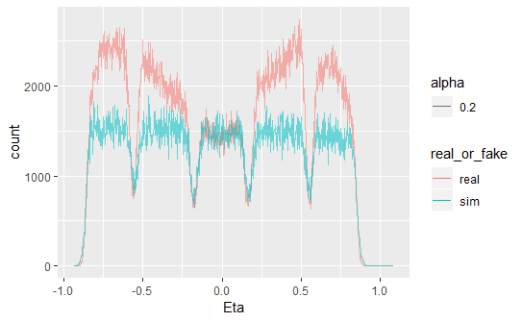

Figure 75: Eta distributions for real and Geant4 simulated data

${nσ}_{π}$ estimates from the Time Projection Chamber (TPC) were dissimilar for real and simulated data ( ${nσ}_{π}$ = -999 is an error flag).

The following cut on ${nσ}_{π}$ was applied to real and simulated data:

$${|nσ}_{π}|≤3$$

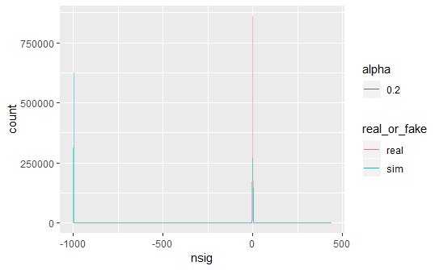

Figure 76: ${nσ}_{π}$ estimate (TPC) distributions for real and Geant simulated data, before cut

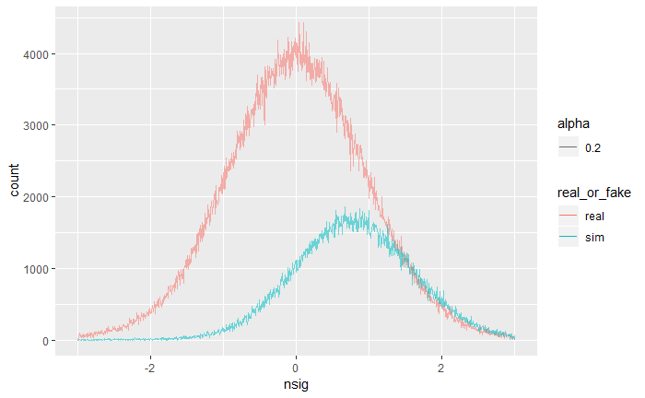

Figure 77: nsigma pion distributions after applying cut

Momentum ranges for real and simulated data were also quite dissimilar, the following cut on momentum was applied to both real and simulated data:

$$1.5≤P≤20$$

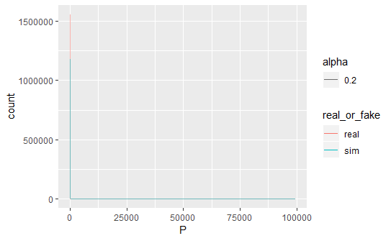

Figure 78: Momentum distributions for both real and Geant4 simulated data, before cut

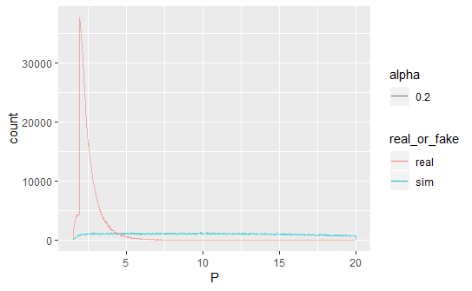

Figure 79: Momentum distributions after cut

### Distinguishing Geant4-simulated Pions from Real Pions

The task of distinguishing simulated from real data was performed using a 2D convolutional neural network, with architecture shown in Figure 81.

Distinguishing Geant4 simulations from real data proved to be a much easier task than distinguishing real electrons from real pions, as depicted in the training graphs in Figure 80.

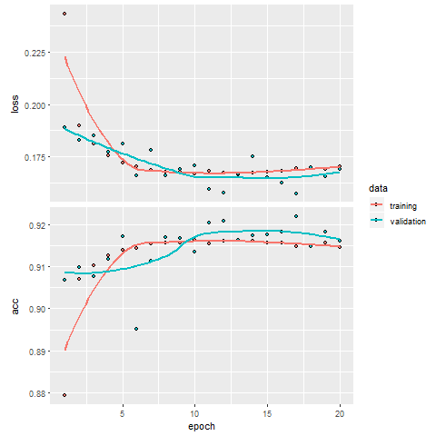

Figure 80: Training loss and accuracy curves for training and validation data

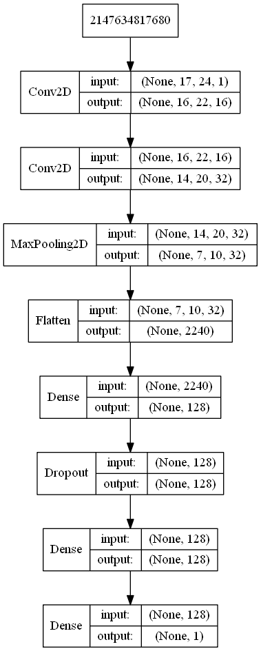

Figure 81: Model architecture for distinguishing real from Geant4-simulated data

Table 4 shows the obtained confusion matrix for the following model architecture:

Table 4: Confusion Matrix for distinguishing between Geant4 vs Real Data

|  |  |  |
| --- | --- | --- |
| Prediction/Actual | $$π_{geant}$$ | $$π_{real}$$ |
| $$π_{geant}$$ | 42 553 | 681 |
| $$π_{real}$$ | 7 069 | 24 058 |

Distinguishing Geant4 simulated data from real data proved to be trivial compared to distinguishing real pions from real electrons. What follows is an analysis of features between the two datasets to investigate what differentiates them.

Firstly, the mean and standard deviation of ADC values for real and simulated datasets are not the same, i.e. $μ_{sim}=2.178$ $; μ_{real}=4.527$ and $σ_{sim}=11.989$ $; σ_{real}=17.995$. The distribution of simulated data’s ADC values is slightly more skewed to the right than that of real data, i.e. $γ_{1_{sim}}=19.170$ $; γ_{1_{real}}=17.391$. However, the maximum ADC value for both datasets is the same, i.e. $\max_{sim}=\max_{real}=1023$.

Figure 82 and Figure 83 show the distribution of ADC values for simulated and real data, respectively.

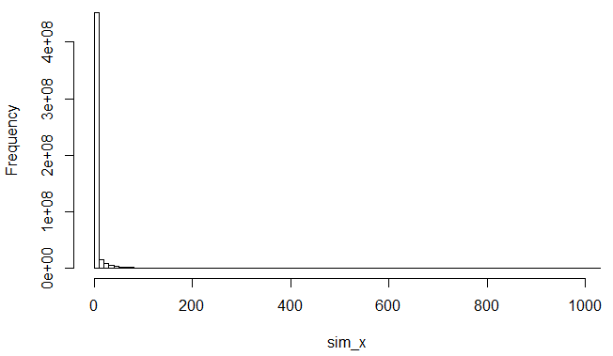

Figure 82: Distribution of ADC values for simulated data

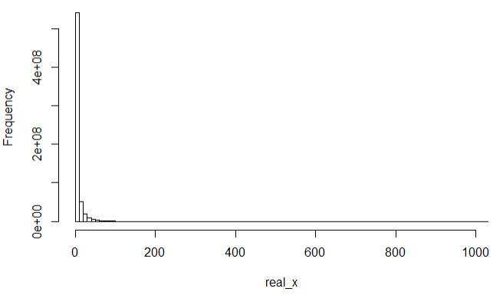

Figure 83: Distribution of ADC values for real data

Looking at the number of pads that don’t contain any data (i.e. the number of rowsums of the image that are equal to 0), one sees the following distributions for simulated and real data:

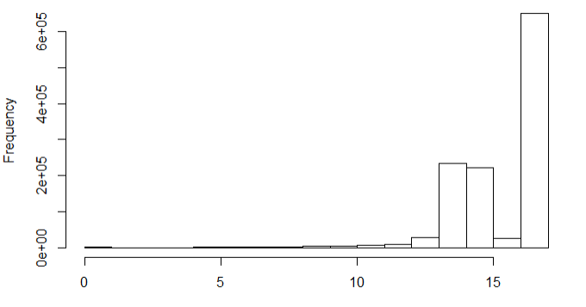

Figure 84: Distribution of the number of pads with no data per image for simulated data

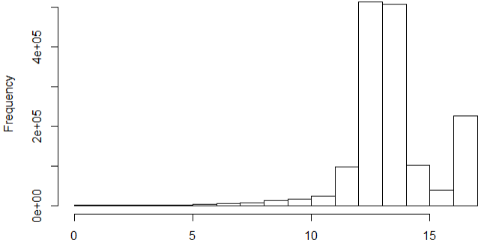

Figure 85: Distribution of the number of pads with no data per image for real data

While these distributions are quite similar, one can see that real data is slightly more skewed towards the left and has far fewer instances of images which are completely devoid of signal, i.e. all pixels in the image are equal to zero and therefore all 17 pads have no signal.

There are also noticeable differences in the distribution of mean ADC values per pad for real and simulated data (see Figure 86 and Figure 87).

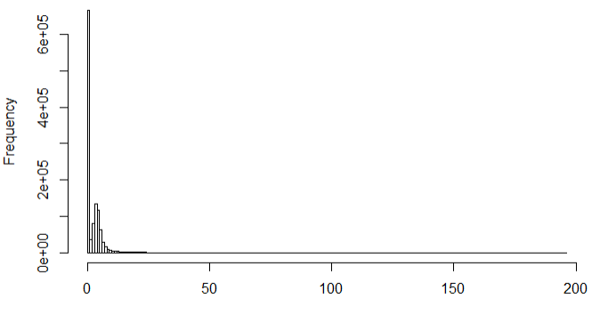

Figure 86: Distribution of mean ADC value per image for simulated data

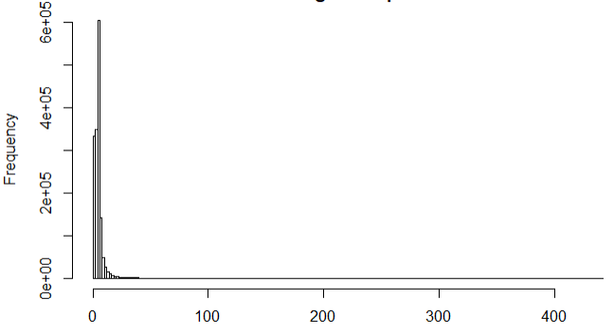

Figure 87: Distribution of mean ADC value per image for real data

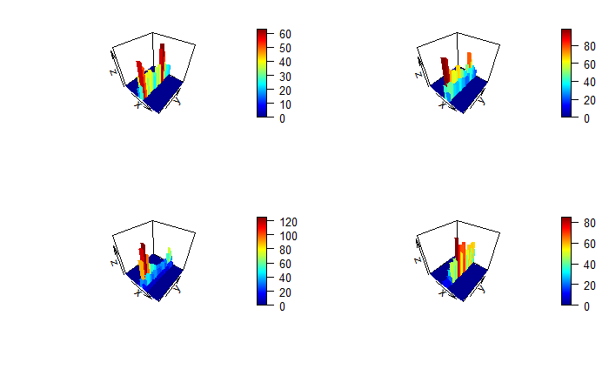

Figure 88: 3D Histograms of Four Randomly Sampled Geant4 Pion Tracklets

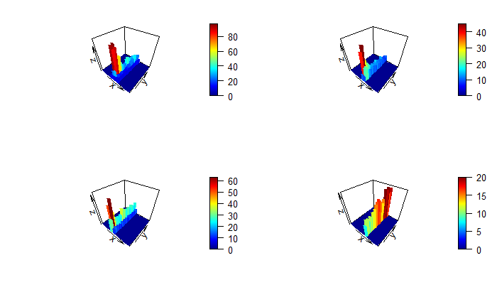

Figure 89: 3D Histograms of Four Randomly Sampled Real Pion Tracklets

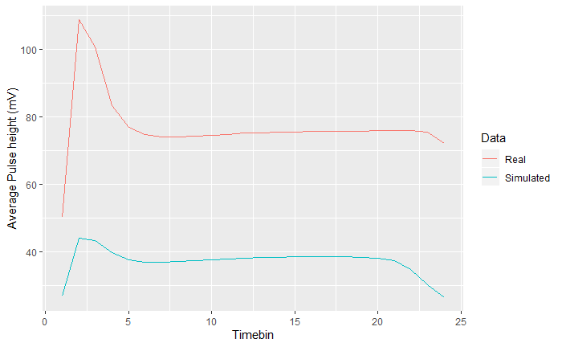

Figure 90: Average Pulse-height as a function of time-bin for Real and Geant4-simulated pion tracklets

## Deep Generative Models Towards Event Simulation

Towards developing a prototype for event simulation, the following models were built:

* Autoencoders
* Variational Autoencoders
* Various types of Generative Adversarial Networks

The following repositories contain code used to build and run Deep Generative Models for this project:

<https://github.com/PsycheShaman/deep-gen>

<https://github.com/PsycheShaman/Keras-GAN> (forked from <https://github.com/eriklindernoren/Keras-GAN> and adapted to be able to work with data from this project).

### Variational Autoencoders

Although various VAEs were prototyped, the following architecture produced the best results:



Figure 91: Encoder

Encoder returns the $μ$ for each of the 100 latent dimensions, , which is calculated as $μ×$ 0.5; and $z$, which is the result of multiplying a random normal vector $ε$ with $e^{\sum{ }}$ and adding $μ$, i.e.

$$z=\left(ε×e^{\sum{ }}\right)+μ$$

The input to the decoder is a sampled z vector as defined above.



Figure 92: Decoder

Below are four examples of simulated tracklet image data, produced by the VAE as explained above.





Figure 93: Four examples of simulated data created using a Variational Autoencoder

##### Deep Learning Towards Distinguishing Variational Autoencoder Data from Real Data

While these results look quite believable at first glance, it was quite easy to distinguish 100 000 real data samples vs 100 000 samples simulated with VAE using a CNN to 100% accuracy, as can be seen in Figure 94.

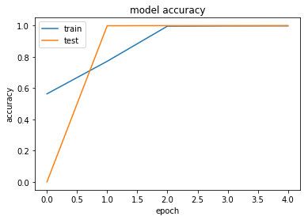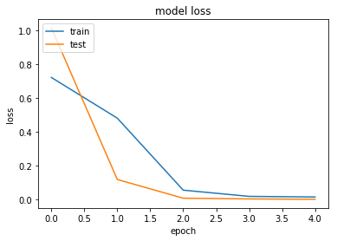

Figure 94: Training accuracy and loss curves for training vs validation data

### Generative Adversarial Networks: Stage One (Adapting Out-of-the-box Networks to this Problem)

Below is a quick summary of the various Deep Generative Models used under the broader GAN category; which also shows how adjusting certain parameters lead to different results, illustrated by the accompanying images.

#### Adversarial Autoencoder

##### Version 1

10 Latent dimensions

Adam optimizer with learning rate = 0.002 and beta1 = 0.5

Batch size = 32

Encoder with 2 hidden layers with 512 nodes each, using leaky ReLU activation

Decoder with 2 hidden layers with 512 nodes each, using leaky ReLU activation and an output layer with tanh activation

Discriminator with two hidden layers, with 512 and 256 nodes respectively and sigmoid activation in the single-node output layer

Sample result after 19800 epochs:

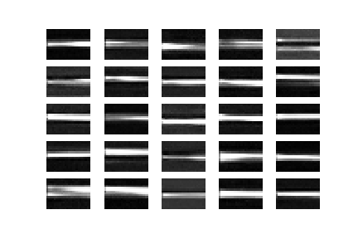

##### Version 2

100 Latent dimensions

Adam optimizer with learning rate = 0.00002 and beta1 = 0.5

Batch size = 32

Encoder with 3 hidden layers with 512 nodes each, using leaky ReLU activation

Decoder with 3 hidden layers with 512 nodes each, using leaky ReLU activation and an output layer with tanh activation

Discriminator with two hidden layers, with 512 and 256 nodes respectively and sigmoid activation in the single-node output layer

Sample result after 30800 epochs:

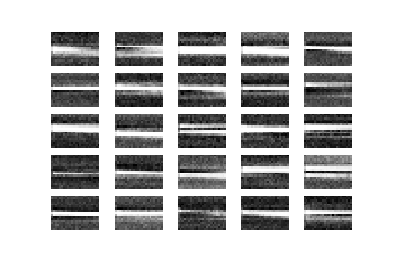

##### Version 3

8 Latent dimensions

Adam optimizer with learning rate = 0.000002 and beta1 = 0.5

Batch size = 32

Encoder with 7 hidden layers with 1024, 512, 256, 128, 64, 32 and 16 nodes respectively, using leaky ReLU activation

Decoder with 4 hidden layers with 128, 256, 512 and 1024 nodes respectively, using leaky ReLU activation and an output layer with tanh activation

Discriminator with 4 hidden layers, with 1024, 512, 256 and 128 nodes respectively and sigmoid activation in the single-node output layer

Sample result after 23600 epochs:

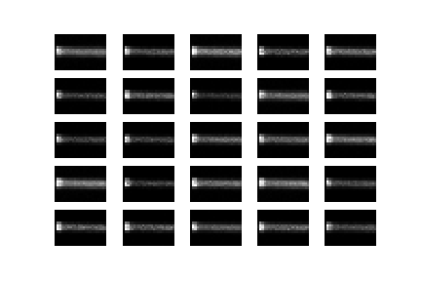

##### Version 4

12 Latent dimensions

Adam optimizer with learning rate = 0.000002 and beta1 = 0.5

Batch size = 32

Encoder with 5 hidden layers with 1024, 512, 512, 128 and 128 nodes respectively, using leaky ReLU activation

Decoder with 4 hidden layers with 256, 256, 512 and 1024 nodes respectively, using leaky ReLU activation and an output layer with tanh activation

Discriminator with 8 hidden layers, with 512 nodes each and sigmoid activation in the single-node output layer

Sample result after 73200 epochs:

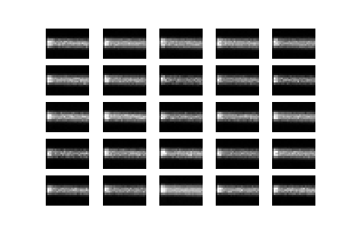

#### Bidirectional Generative Adversarial Network

100 Latent dimensions

Encoder with 2 hidden layers with 512 units each, using Leaky ReLU activation and employing Batch Normalization with momentum = 0.8 after each

Generator with the same architecture as the encoder, with an additional dense layer of the same dimensions as the number of pixels in an image, with tanh activation

Discriminator with 3 hidden layers with 1024 nodes each using leaky relu activation and a single node output layer with sigmoid activation function

Trained using Adam Optimizer with Learning Rate = 0.0002 and Beta1=0.9 and a batch size of 32

Example output after 39600 epochs:

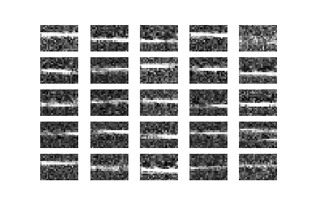

Deep Convolutional Generative Adversarial Network

100 Latent dimensions

Generator with Dense layer with 3072 nodes, reshaped to $4×6×128$ with 2D Upsampling, followed by 3 2D convolutional layers, with the first two followed by Batch normalization and 2D Upsampling, using ReLU activation in the first 4 layers and tanh in the final output layer

Discriminator with 4 2D convolutional layers, with Batch Normalization applied after the second, third and fourth layer and zero-padding after the second layer, using leaky ReLU activation in the hidden layer and sigmoid in the output node.

Example output after 57500 epochs:

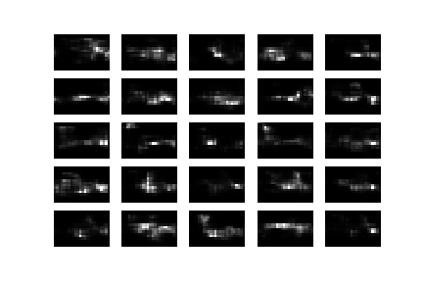

Generative Adversarial Network

100 Latent dimensions

Two separate Adam Optimizers used for Generator and Discriminator, i.e. with learning rate = 0.00002 and beta1=0.5 for Discriminator and learning rate = 0.00001 and beta1=0.5 for Generator

Generator with 12 hidden layer with 100, 200, 300, 400, 500, 600, 700, 800, 900, 1000, 1100,1200 hidden units, using leaky ReLU activation and a dense output layer of the desired output image dimensions with tanh activation, including Batch Normalization with momentum = 0.8 after each hidden layer

Discriminator with 7 hidden layers with 1024, 1024, 512, 512, 256, 256 and 128 units, respectively, using leaky ReLU activation and a single node output layer using sigmoid activation.

Example Output after 66400 epochs:

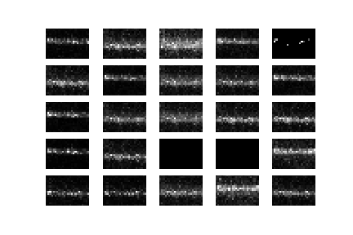

Least Squares Generative Adversarial Network

100 Latent dimensions

Adam Optimizer with learning rate = 0.00002 and beta1 = 0.5 using batch size = 32

Generator with 6 hidden dense layers with 256, 256, 512, 512, 1024 and 1024 hidden layers using leaky ReLU activation and an output layer with tanh activation, using Batch Normalization with momentum = 0.8 after each hidden layer

Discriminator with 8 hidden layers with 1024, 1024, 512, 512, 256, 256, 128 and 128 hidden layer and a single node output layer with no activation function

Example output after 64600 epochs:

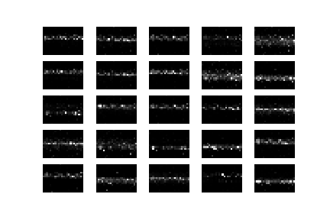

### GANs Stage 2

#### GAN “Hacks”

# Discussion and Conclusions

## Discussion

### Particle Identification Using Deep Learning

#### Accuracy Paradox

As mentioned, when extremely large class imbalances are not accounted for, misleadingly good results may appear to occur during training (see Figure 95), but this level of accuracy just reflects the ratio of the classes in the dataset we’re working with (the model learns that it gets the lowest loss when it favours the prediction of pion, since there are so many more pions in our dataset, compared to electrons). This phenomenon is known as the “Accuracy Paradox”.

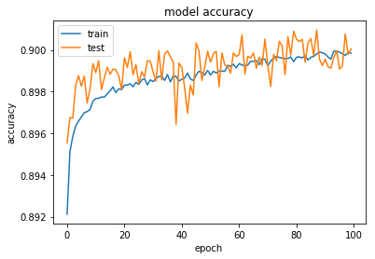

Figure 95: Accuracy Paradox

#### Inherent Limit on the Amount of Information Contained about the Class Label

One of the most salient features of the data used in this project is the inherent limit of the amount of information that the input features $x$ contain about the target feature $y$.

There seems to be an absolute limit at around 75% training accuracy, regardless of:

* which architecture was used (Figure 96, Figure 97 and Figure 98 show how this problem is potentially solvable by 2D Convolutional, LSTM and 1D Convolutional Neural Networks)

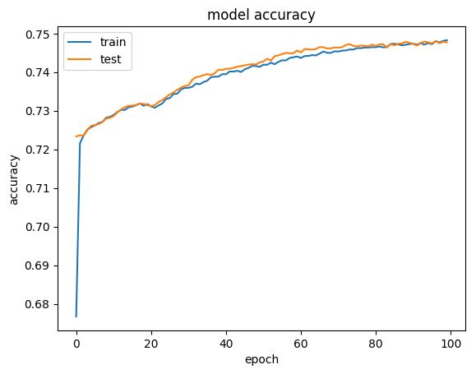

Figure 96: Example of a 2D-Convolutional Network training to high validation accuracy

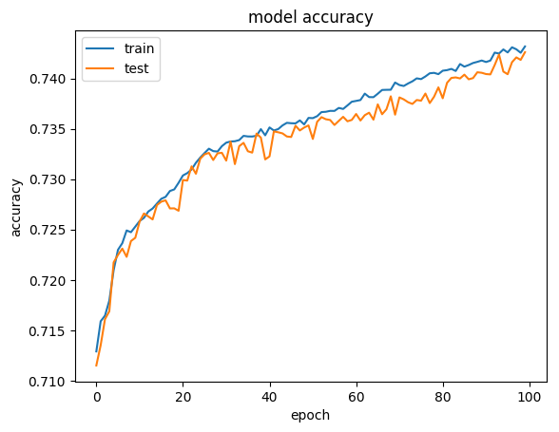

Figure 97: Example of an LSTM Network training to high validation accuracy

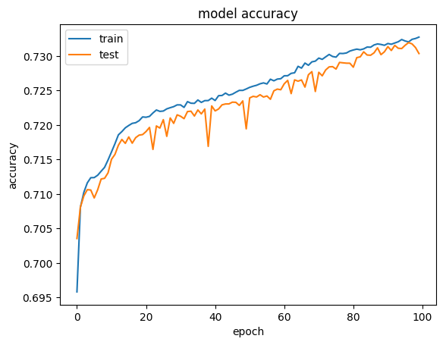

Figure 98: Example of a 1D-Convolutional Neural Network training to high validation accuracy

* the amount of epochs used for training (Figure 99 shows how training a highly successful model for twice the number of epochs only results in eventual overfitting)

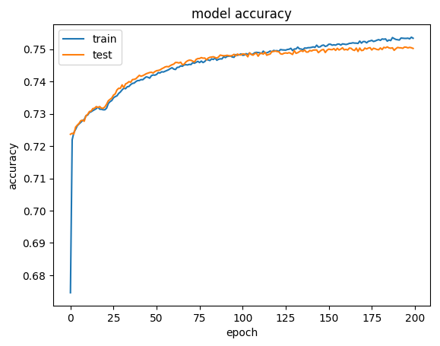

Figure 99: Running a successful model for twice the number of epochs results in minimal gains and eventually, results in overfitting

#### Convolutional Neural Networks

Regardless of the limitations outlined above, 2D convolutional neural networks resulted in the highest performance in general, but interestingly, even a very simplistic convolutional neural network (one convolutional layer, using 16 convolutional filters with kernel size equal to image dimensions, i.e. $17×24$ and a single dense layer with 12 nodes) still gave comparable results, i.e. $ε_{π}=6.2\%$.

#### 1D Convolutional Neural Networks

While 2D Convolutional Neural Networks were more successful than 1D Convolutional Neural Networks, 1D CNNs resulted in similar performance, even though they were fed data with lower dimensions, i.e. a compressed version of the data 2D CNNs were trained on, in the form of column sums of the original 2D image data. It should be noted that many more 2D CNNs were built during this project, but the fact that 1D CNNs gave comparable accuracy provides additional suspicion that there is a limit to the amount of information contained in the 2D images from the TRD about the Particle ID.

#### LSTM Networks

The nature of this dataset is such that it can be framed as an image for Convolutional Neural Networks, but it is essentially a timeseries as well, with columns going across indicating the ADC signal at sequential time intervals and rows indicating where the charge was deposited (in which pad in a specific TRD chamber, row and column).

The lowest pion efficiency using LSTM networks was $ε_{π}=8.5\%$, which is much higher than that achieved by the best 2D Convolutional Neural Networks. This was achieved by having 4 LSTM layers return sequences sequentially, followed by a final LSTM network which fed into a dense architecture of 5 fully connected layers of 128 nodes each; although similar performance ($ε_{π}=8.9\%$) was obtained using only two LSTM layers, with the second layer going backwards, followed by four dense layers of 256 nodes each. Using 6 LSTM layers, alternating between going backwards and forwards, with four dense layers of 256 nodes each made pion efficiency drop back down to $ε_{π}=9.2\%$.

#### The Effect of Regularization

Figure 100 shows the effect of applying too much Dropout at training time. The left side of the figure shows a model which overfit during training and the right hand side shows the effect of applying a Dropout rate of 0.5 to each layer of the same network.

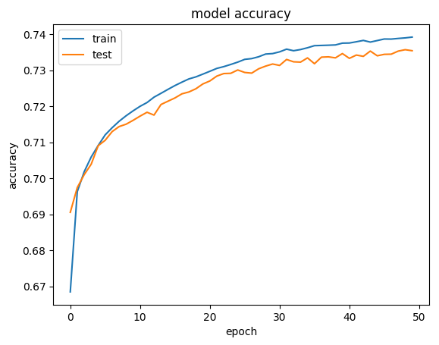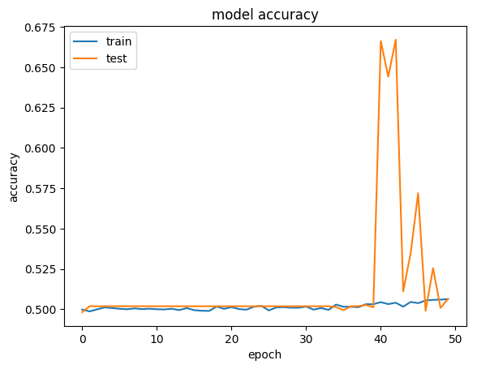

Figure 100: No Dropout vs Same Model with too much Dropout

In general, using a Dropout rate of 0.2 on the fully connected layers of the network proved to be a decent strategy, bearing in mind that other hyperparameters also play a role, e.g. a model employing the abovementioned Dropout rate which resulted in a pion efficiency of $ε_{π}=6.5\%$ dropped down to a pion efficiency of $ε_{π}=24.1\%$ when the learning rate (using the Adam optimizer) was reduced from $ϵ={10}^{-4}$ to $ϵ={10}^{-6}$.

The use of a Gaussian Noise layer as the first layer of various convolutional architectures was employed, but was unsuccessful, as depicted in Figure 101. All models that incorporated Gaussian noise gave pion efficiencies of $ε_{π}>45\%$. While there was not much experimentation with different standard deviations of the Gaussian noise layer, this method seems more applicable to image data which is less sparse, since it is only active during training time, and since most of the rows in our input data naturally has a value of 0, adding Gaussian noise will only serve to confuse the model when evaluated at test time.

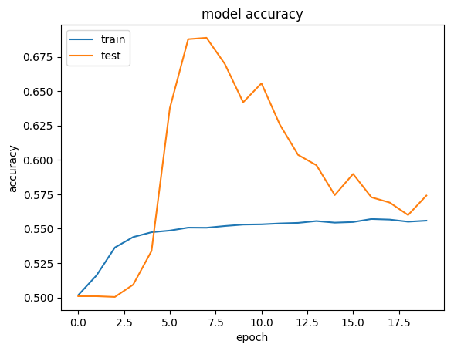

Figure 101: Gaussian Noise with σ=0.2

### Deep Generative Models towards High Energy Physics Event Simulations

#### Challenges faced during deep generative modelling

Running on a server is not practical, since training Deep Generative models requires constant qualitative monitoring, especially when label smoothing is used, monitoring metrics that are informative during classification could be misleading if intermediate output images can’t be viewed and training can be forced stop if the Generative model is outputting unrealistic images.

Not being able to run on a server prevents parallel training of models. Running locally imposes additional constraints in the form of RAM and processing limitations. Loading the full dataset results in an out of memory error.

Tweaking a single hyperparameter to see its effect would be ideal, but time constraints force one to often change multiple hyperparameters and architectures simultaneously. Using one’s intuition as to what the effect of each of a combination of changes induced becomes more important.

While various deep generative architectures can give results that appear vastly different in terms of “style”, they all fail to capture the underlying distribution of the training data sufficiently.

A possible reason for this is that the images used for training are quite small and have relatively little information compared to, for instance, images of human faces, where GANs have proven to be quite successful.

While Variational Autoencoders give images that appear less spread-out along the pad dimension than any of the GAN architectures that were used, with less overall noise, they still fail to capture some of the volatility along the time dimension and appear somewhat “smeared out” compared to real data.

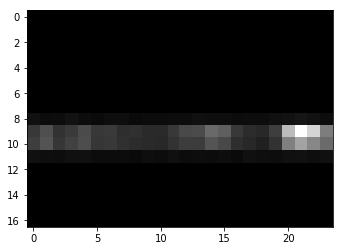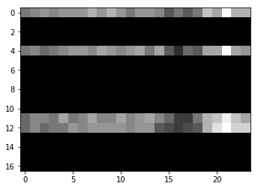

Figure 102: Real images



Figure 103: Autoencoder outputs

While Adversarial Autoencoders gave results that were slightly better than the other GAN architectures experimented with, all of the GAN architectures provided disappointing results, possibly due to the fact that GANs are quite hard to train, since there are two neural networks pitted against each other in such a setup and if either of them become dominant during the training process, they can force the other into a parameter space which is not conducive to training either network properly.

Examples of this can be seen in an Adversarial Autoencoder setup with very deep architecture in both the Generator and Discriminator (Figure 104), where after 21400 epochs, the Generator still outputs images that are seemingly random, but nonetheless have similar features across images (for some reason this resulted in low error and therefore became prevalent). This phenomenon is known as Mode Collapse.

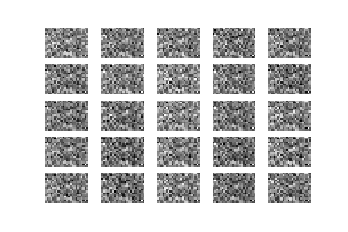

Figure 104: An illustration of Mode Collapse

Batch Normalization is a strategy that ensures that a layer’s outputs are normally distributed and therefore prevents the Generative component of the GAN to output images that look very similar, in Figure 105, one can see that the output images of the Bidirectional GAN (which employs this strategy) are highly dissimilar, but there is still a lot of noise around the main signal.

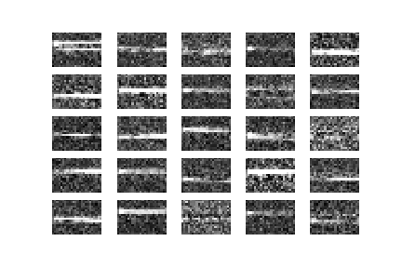

Figure 105: Illustrating the effect of Batch normalization to prevent output images from looking highly similar

It is interesting to note that while one might expect GANs that employ convolutional layers to give better results than fully connected dense layers, the Deep Convolutional GANs gave some of the most unrealistic simulated images (Figure 106). This could be due to the fact that convolutional layers introduce a prior that features are translationally invariant, i.e. they can appear anywhere in the image. While this might be a useful assumption during particle identification, it does not seem to hold for when simulating the data used in this project.

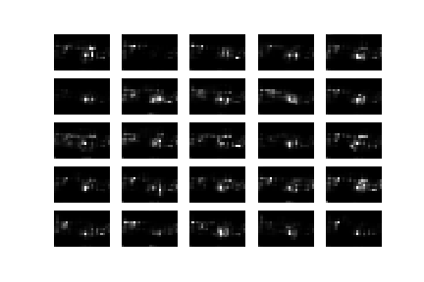

Figure 106: Illustrating how convolutional architectures in a GAN setup results in features that might exist in the training distribution, but do not appear in the right place

Training after a certain number of epochs does not necessarily result in additional gains in performance, as can be seen in Figure 107, Figure 108 and Figure 109, there is not much change in the output of a Least Squares GAN when training for an additional 293 000 epochs after 94 600 epochs and training for an additional 61 400 epochs after that eventually results in images that look less realistic than those produced during earlier epochs.

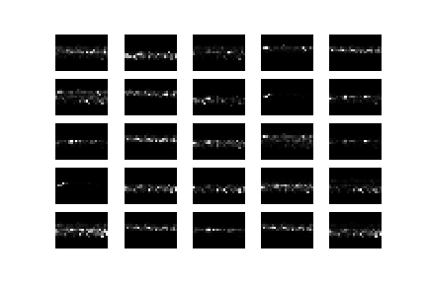

Figure 107: Least squares GAN after 94600 epochs

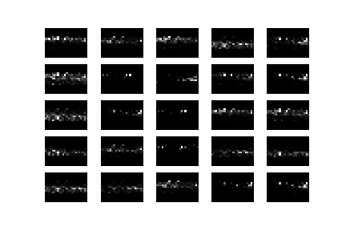

Figure 108: Least squares GAN after 387600 epochs

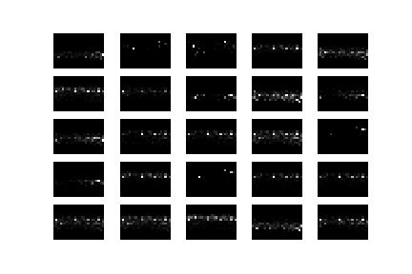

Figure 109: Least squares GAN after 449000 epochs

## Conclusions

### Particle Identification

While neural networks are very good at coming up with their own feature sets to find nested functions that can solve classification problems, what’s more important in a deep learning project is making sure that the input data contains sufficient information about the class label.

While the work done in this project did not achieve comparable results to work done before, pad-per-pad calibration was performed on data in the work done before, which proved to be invaluable in normalizing the data for environmental and electronic variations which occur during data taking and affect how the signal manifests, a process which cannot be solvable by deep learning techniques.

### Simulations

Probably the most important result of this dissertation is the fact that Geant4 simulations are easily distinguishable from real data. Whilst deep generative techniques do not appear to be able to give similar performance compared to Geant4 for this particular problem, there could be interesting ways to combine the two methods, e.g. by transforming the output given by Geant4 with deep generative techniques to make it appear more like real data.

## Outlook and Future Work

### Particle Identification

Future work should focus on applying additional data pre-processing steps before particle identification is applied. The data used for particle identification in this thesis was raw data from the TRD, whereas previous work used data which was calibrated pad-by-pad per run; however there does not seem to be much promise for arriving at increased accuracy using advanced deep learning methods compared to work that was done before

### Simulations

As mentioned in the Conclusions section above, there should be scope to use the output of Geant4 simulations as a latent space to produce more realistic simulations, alternatively, a more realistic approach would entail tuning parameters used during simulation in the following script <https://github.com/alisw/AliRoot/blob/master/TRD/TRDbase/AliTRDSimParam.cxx>, a lot of hard-coded parameters could be adjusted recursively by using the loss function of a neural network which is used to distinguish between the two data sets as a parameter to be maximized, i.e. to produce simulated data that becomes harder to distinguish from real data as the multidimensional input parameters maximize the loss function of the discriminating neural network more, a setup similar to what occurs in GANs.

### Outlook

Tensorflow and the Keras library are immensely useful for rapid prototyping of various deep learning architectures, whether they be for classification or regression problems. Whilst there exists a toolkit for machine learning within the AliRoot infrastructure, there should be benefits to exploring how using more modern deep learning libraries within the environment of AliRoot could extend its capabilities as Machine Learning becomes a more mature and effective field.

# Bibliography

|  |  |
| --- | --- |
| [1] | M. Thomson, “Modern Particle Physics,” 2013. |
| [2] | J. Rafelski, “Connecting QGP-Heavy Ion Physics to the Early Universe,” in *Nuclear Physics B Proceedings Supplement*, 2013. |
| [3] | C. G. Viljoen. [Online]. Available: https://www.draw.io/?lightbox=1&highlight=0000ff&edit=_blank&layers=1&nav=1#G1X-ZGzxO_b4zo_74rY9Z9zaikz-Il6R8o. |
| [4] | H. Satz, “The Quark-Gluon Plasma∗ A Short Introduction,” in *6th International Conference on Physics and Astrophysics of Quark Gluon Plasma*, 2011. |
| [5] | “QCD Phase Diagram SVG,” [Online]. Available: https://commons.wikimedia.org/wiki/File:QCDphasediagram.svg. [Accessed 18 2 2019]. |
| [6] | “Week 3: Thermal History of the Universe,” [Online]. Available: www.astro.caltech.edu/~george/ay127/kamionkowski-earlyuniverse-notes.pdf. [Accessed 20 February 2019]. |
| [7] | The Steven Hawking Center for Theoretical Cosmology, [Online]. Available: http://www.ctc.cam.ac.uk/images/contentpics/outreach/cp_universe_chronology_large.jpg. |
| [8] | CERN, “About CERN: Who we are: Our History,” CERN, [Online]. Available: https://home.cern/about/who-we-are/our-history. [Accessed 26 January 2019]. |
| [9] | CERN, “CERN: Who We Are: Our Governance: Member States,” [Online]. Available: https://home.cern/about/who-we-are/our-governance/member-states. [Accessed 26 January 2019]. |
| [10] | CERN, “CERN: About: Who We Are: Our Mission,” [Online]. Available: https://home.cern/about/who-we-are/our-mission. [Accessed 26 January 2019]. |
| [11] | CERN, “CERN Resources: FAQs: Facts and Figures About the LHC,” [Online]. Available: https://home.cern/resources/faqs/facts-and-figures-about-lhc. [Accessed 06 01 2019]. |
| [12] | University of California Davis, “RHIC,” [Online]. Available: http://nuclear.ucdavis.edu/~rpicha/rhic.html. [Accessed 27 01 2019]. |
| [13] | Encyclopedia Britannica, “Tevatron Particle Accelerator,” [Online]. Available: https://www.britannica.com/technology/Tevatron. [Accessed 27 January 2019]. |
| [14] | M. Masuzawa, H. Koiso, K. Oide, R. Sugahara and et al., “CIRCUMFERENCE VARIATIONS OBSERVED AT KEKB,” in *Proceedings of the 7th International Workshop on Accelerator Alignment*, 2002. |
| [15] | S. Chardley, “LHC Does a Dry-Run,” 20 March 2015. [Online]. Available: https://www.symmetrymagazine.org/article/march-2015/the-lhc-does-a-dry-run. [Accessed 26 January 2019]. |
| [16] | S.-I. Kurokawa and S. L. Olsen, “The KEK B-Factory Experiment,” [Online]. Available: www.slac.stanford.edu/pubs/beamline/29/2/29-2-kurokawa.pdf. [Accessed 27 January 2019]. |
| [17] | Taking a Closer Look at the LHC, “The LHC Proton Source,” [Online]. Available: https://www.lhc-closer.es/taking_a_closer_look_at_lhc/0.proton_source. [Accessed 27 January 2019]. |
| [18] | CERN, “LHC: The Guide,” [Online]. Available: https://home.cern/resources/brochure/cern/lhc-guide. [Accessed 2017 January 2019]. |
| [19] | CERN, “The CERN Accelerator Complex,” [Online]. Available: https://cds.cern.ch/record/2636343/files/CCC-v2018-print-v2.jpg?subformat=icon-1440. [Accessed 26 January 2019]. |
| [20] | CERN, “LHC Experiments,” [Online]. Available: https://home.cern/science/experiments. [Accessed 21 February 2019]. |
| [21] | CERN, “ATLAS Experiment,” [Online]. Available: https://home.cern/science/experiments/atlas. [Accessed 21 February 2019]. |
| [22] | CERN, “ALICE Experiment,” [Online]. Available: https://home.cern/science/experiments/alice. [Accessed 21 Fenruary 2019]. |
| [23] | CERN, “LHCb Experiment,” [Online]. Available: https://home.cern/science/experiments/lhcb. [Accessed 21 February 2019]. |
| [24] | CERN, “ROOT Data Analysis Framework: User's Guide,” May 2018. [Online]. Available: https://root.cern.ch/root/htmldoc/guides/users-guide/ROOTUsersGuideA4.pdf . |
| [25] | [Online]. Available: https://root.cern.ch/. |
| [26] | “ROOT 5 Reference Guide,” [Online]. Available: https://root.cern/root/html534/ClassIndex.html. |
| [27] | “ROOT 6 Reference Guide,” [Online]. Available: https://root.cern/doc/v616/. |
| [28] | ALICE Collaboration (CERN), [Online]. Available: https://alice-doc.github.io/alice-analysis-tutorial. [Accessed 18 2 2019]. |
| [29] | CERN, “High Energy Physics Simulations,” [Online]. Available: http://lhcathome.web.cern.ch/projects/test4theory/high-energy-physics-simulations. [Accessed 26 July 2019]. |
| [30] | S. Agostinelli, J. Allison, J. Apostolakis and P. Arce, “Geant4 - a simulation toolkit,” *Nuclear Instruments and Methods in Physics Research,* vol. A 506, pp. 250-303, 2003. |
| [31] | Particle Data Group, The Review of Particle Physics, 2018. |
| [32] | ALICE Collaboration, The ALICE Transition Radiation Detector: construction, operation, and performance, CERN, 2017. |
| [33] | ALICE, “ALICE Homepage,” [Online]. Available: http://alice.web.cern.ch/. [Accessed 21 February 2019]. |
| [34] | CERN, [Online]. Available: https://cds.cern.ch/record/2302924. [Accessed 21 February 2019]. |
| [35] | The ALICE Collaboration, The ALICE Experiment at the CERN LHC, INSTITUTE OF PHYSICS PUBLISHING AND SISSA, 2008. |
| [36] | The ALICE Collaboration, The Technical Design Report of the Transition Radiation Detector, Geneva: CERN, 2001. |
| [37] | Y. Pachmayer, “Particle Identification with the ALICE Transition Radiation Detector,” 2014. |
| [38] | I. Goodfellow, Y. Bengio and A. Courville, Deep Learning, Cambridge, Masachusetts: The MIT Press, 2016. |
| [39] | F. Rosenblatt, “The Perceptron: A Probabilistic Model for Information Storage and Organization in the Brain,” *Psychological Review,* vol. 65, no. 6, 1958. |
| [40] | keras.io, “Available Activations,” [Online]. Available: https://keras.io/activations/#available-activations. [Accessed 19 July 2019]. |
| [41] | C. Viljoen. [Online]. Available: https://www.draw.io/?lightbox=1&highlight=0000ff&edit=_blank&layers=1&nav=1#G1Zbad00aGA6OXlYpDzl8ggBK2kRM08xzO. |
| [42] | C. Doersch, “Tutorial on Variational Autoencoders,” ResearchGate, 2016. |
| [43] | I. Goodfellow, J. Pouget-Abadie, M. Mirza, B. Xu, D. Warde-Farley, S. Ozair, A. Courville and Y. Bengio, “Generative Adversarial Nets,” 2014. |
| [44] | A. Odena, C. Olah and J. Shlens, “Conditional Image Synthesis with Auxiliary Classifier GANs,” in *Proceedings of the 34th International Conference on Machine Learning*, 2017. |
| [45] | A. Makhzani, I. Goodfellow, B. Frey, J. Shlens and N. Jaitly, “Adversarial Autoencoders,” 2016. |
| [46] | J. Donahue, T. Darrell and P. Krahenbuhl, “Adversarial Feature Learning,” 2017. |
| [47] | L. Metz, A. Radford and S. Chintala, “Unsupervised Representation Learning with Deep Convolutional Genarative Adversarial Networks,” in *ICLR 2016*, 2016. |
| [48] | X. Mao, Q. Li, Xi, Haoran, R. Lao, Z. Wang and S. P. Smolley, “Least Squares Generative Adversarial Networks,” 2017. |
| [49] | G. Cowan, Statistical Data Analysis, Oxford: Oxford University Press, 1998. |
| [50] | T.-Y. Lin, P. Goyal, R. Girshick, K. He and P. Dollar, “Focal Loss for Dense Object Detection,” *Computer Vision and Pattern Recognition,* 2018. |
| [51] | U. Griffo, “Umberto Griffo - Focal Loss Keras,” [Online]. Available: https://github.com/umbertogriffo/focal-loss-keras. |
| [52] | C. Viljoen, “Psyche Shaman - Custom Focal Loss Keras R,” [Online]. Available: https://gist.github.com/PsycheShaman/ea39081d9f549ac410a3a8ea942a072b. |
| [53] | [Online]. Available: https://commons.wikimedia.org/wiki/File:Standard_Model_Feynman_Diagram_Vertices.png. [Accessed 2 March 2019]. |
| [54] | CERN, “Grafana IT Overview,” [Online]. Available: http://monit-grafana-open.cern.ch/d/000000884/it-overview?orgId=16. [Accessed 26 January 2019]. |
| [55] | R. Field, “PHY2061 - Enriched Physics 2 - Relativity 4,” [Online]. Available: http://www.phys.ufl.edu/~acosta/phy2061/lectures/Relativity4.pdf. [Accessed 27 January 2019]. |
| [56] | CERN, “LHCf Experiment,” [Online]. Available: https://home.cern/science/experiments/lhcf. [Accessed 21 Febraury 2019]. |
| [57] | CERN, “MoEDAL Experiment,” [Online]. Available: https://home.cern/science/experiments/moedal. [Accessed 21 Febrary 2019]. |
| [58] | CERN, “Physics Vectors,” [Online]. Available: https://root.cern.ch/root/htmldoc/guides/users-guide/PhysicsVectors.html. [Accessed 23 February 2019]. |
| [59] | “Spherical Coordinates,” [Online]. Available: https://mathinsight.org/spherical_coordinates. [Accessed 23 February 2019]. |
| [60] | S. Hochreiter and J. Schmidhuber, “Long Short-Term Memory,” *Neural Computation,* vol. 9, no. 8, pp. 1735-1780, 1997. |
| [61] | S. Weinberg, The First Three Minutes, Cambridge, Masachusettes: Fontana Paperbacks, 1976. |
| [62] | D. Robinson. [Online]. Available: http://donrmath.net/CalcIII/unit1/lesson7/u1l7.html. [Accessed 23 February 2019]. |
| [63] | “NN SVG,” [Online]. Available: http://alexlenail.me/NN-SVG/AlexNet.html. [Accessed 21 April 2019]. |
| [64] | [Online]. Available: h2o.ai. |

Appendix A